

**ADAMA SCIENCE AND TECHNOLOGY UNIVERSITY**

**SCHOOL OF ELECTRICAL ENGINEERING**

**AND COMPUTING (SOEEC)**

**SENIOR PROJECT SUBMITTED FOR THE PARTIAL FULFILLMENT OF BACHELOR OF SCIENCE IN COMPUTER SCIENCE AND ENGINEERING**

**PROJECT TITLE: Beer Sales and Distribution System for BGI Ethiopia.**

**Name ID**

1.Ephrem Daniel A/UR14306/10

2.Efrem Yohanis A/UR14623/10

3Natnael Desta A/UR14886/10

4.Israel Getachew A/UR15020/10

5.Kaleb Melkamu A/UR14475/10

**Advisor: Mr. Kibrom Tadesse Signature**

**Submitted by**

Israel Getachew **_**_________________________ Feb3, 2022

Student Signature Date

Ephrem Daniel__________________________ Feb3, 2022

Student Signature Date

Efrem Yohanis__________________________ Feb3, 2022

Student Signature Date

Natnael Desta__________________________ Feb3, 2022

Student Signature Date

Kaleb Melkamu __________________________ Feb3, 2022

Student Signature Date

## Acknowledgement

We would like to express our very great appreciation to Kibrome Tadese for his valuable and constructive suggestions during the process of writing this document. His willingness to give his time so generously is very much appreciated.

We would like to offer our special thanks to computer science and engineering department and to the school of electrical engineering and computing for their assistance and help.

We would also like to thank the staff of the following organizations for enabling me to visit their offices to observe their daily operations:

* Gebre E/gr Gebre Selassie: BGI Ethiopia Agent Adama
* Mr Kibret : BGI Ethiopia Promoter in Adama

Team Members

## Abbriviations and Acronyms

BGI Brassiers Group Internation

BSDS…………………………………………………………….Beer Sales and Distribution System

UI User Interface

HTML Hyper Text Markup Language

CSS Cascading Style Sheets

DOM Document Object Model

JS JavaScript

PC Personal Computer

RAM Random Access Memory

UML Unified Modeling Language

ID Identification

PLC Private Limited Company

UAE United Arab Emirates

USA Unites States of America

UK United Kingdom

admin Administrator

etc Et Cetera

Table of Contents

Acknowledgement 3

Abbriviations and Acronyms 4

List of figures 7

List of Table 9

Chapter one 10

1.2 Background of the organization 10

1.2.1 Mission of the organization 11

1.2.2 Vision of the organization 11

1.3 Background of the project 11

1.4 Justification of the 12

1.5 Objective of the 12

1.6 Scope and limitation 13

1.7 Feasibility study 13

1.7.1 Technical feasibility 13

1.7.2 Operational feasibility 14

1.7.3 Economic feasibility 14

1.8 Significance of the project 14

1.9 Beneficiaries of the project 14

1.11 Development tools 15

1.12 Required resources with 16

1.13 Task and Schedule 17

1.14 Team composition 18

Chapter Two: Description of the existing system 19

2.1. Major functions of the existing system 19

2.2 Users of the current system 21

2.3 Drawback of the current system 24

2.4. Business rule 24

Chapter 3: Proposed System 26

3.1 Overview 26

3.2 Functional 26

3.3 Non-functional requirement 26

3.4 System model 26

3.4.1 Scenarios 27

3.4.2 Use case model 30

3.5 Object model 41

3.5.1 Data dictionary 41

3.5.2 Class diagram 42

3.5.3 Dynamic model 43

3.5.4 Sequence diagram 43

3.5.5 Activity diagram 55

4.1 overviewChapter Four: System Design 70

4.1.1. Purpose of the system design 70

4.1.2. Design Goal 70

4.2. Proposed System Architecture 71

Chapter 5: Implementation 81

5.2 Coding Standard 81

5.3 Development Tools 82

5.4 Prototype 82

5.5 Implementation detail 83

5.6 Testing Plan 84

*References* 87

## List of figures

Figure 1 Work flow of current system 18

Figure 2 Uscase diagram 38

Figure 3 class diagram 39

Figure 4 Sequence diagram Registration 40

Figure 5 Sequence diagram Login 41

Figure 6 Sequence diagram for Customer place order 42

Figure 7 Sequence diagram for send delivery status 43

Figure 8 Sequence diagram for view delivery status 44

Figure 9 Sequence diagram for register driver 45

Figure 10 Sequence diagram for distributator to make order 46

Figure 11 Sequence diagram for distributor to assign order 47

Figure 12 Sequence diagram for company login 48

Figure 13 Sequence diagram for company add distributor 49

Figure 14 Sequence diagram for company to post for advertisment 50

Figure 15 Sequence diagram for company to generate report 51

Figure 16 Assign order for distributor 52

Figure 17 User sign up to be a disributor 53

Figure 18 user sign up to be a customer 53

Figure 19 user login as customer 54

Figure 20 user place order 54

Figure 21 sending delivery report 55

Figure 22 user rating distributor 55

Figure 23 viwing assign order 56

Figure 24 user making order 56

Figure 25 user viwing delivery report status 57

Figure 26 assining deriver 57

Figure 27 Admin login 58

Figure 28 Add distributor 58

Figure 29 report generation 59

Figure 30 Posting Adverstisment 59

Figure 31 State chart diagram for signup 60

Figure 32 State chart diagram for Login 61

Figure 33 State chart diagram for Distributor order 62

Figure 34 State chart diagram to add distributor 63

Figure 35 State chart diagram to post advertisement 64

Figure 36 65

Figure 37 State chart diagram to Generate report 66

Figure 38 system overview 69

Figure 39 client-server architecture for BSDS 69

Figure 40 complete system process diagram 70

Figure 41 subsystem decomposition 70

Figure 42 Hardware - Software Mapping 71

Figure 43 persistent data management model 71

Figure 44 object mapping customer 72

Figure 45 object mapping admin 72

Figure 46 object mapping-agent 73

Figure 47 object mapping sales and finance admin 73

Figure 48 component diagram 74

Figure 49 database design 75

Figure 50 user interface design 77

Figure 51 prototype 1 79

Figure 52 prototype 2 80

## List of Table

Table 1 : Required resources with cost 16

Table 2 : Task and schedule 16

Table 3 Team composition 16

Table 4 Usecase description login 29

Table 5 Usecase description Add distributor 29

Table 6 Usecase description Generate report 30

Table 7 Usecase description Post advertisement 31

Table 8 Usecase description View Request order 31

Table 9 Usecase description View Delivery Status 32

Table 10 Usecase description Register driver 33

Table 11 Usecase description Assign order 33

Table 12 Usecase description Make order 34

Table 13 Usecase description Place order 35

Table 14 Usecase description Send delivery status 36

Table 15 Usecase description Rate distributor 36

Table 16 Usecase description Logout 37

Table 17 priority of the system 68

Table 18 implementation detail 80

# Chapter one

1.1. **Introduction**

In our country, there are a lot of beer companies that are committed to producing products and deliver to their customers. Each of them have their distribution and sales mechanisms to reach their end customers. Among them, BGI Ethiopia is one of the beer companies in Ethiopia that have four bottle beer products namely St. George, castle, Doppel, and Senq’ along with other products.

BGI Ethiopia does not sell its products directly to end-users. Mass production, consumption, and distribution rely on agents, representatives, retailers, brokers, or some combination of these intermediaries to distribute their products. These intermediaries perform a variety of functions and constitute a marketing channel that referred to a trade channel, or distribution channel.

Without having a standardized distribution system, their product will not deliver and the marketing mix will break down and fail. The distribution channel consists of a group of individuals or organizations that assist in getting the product to the right place at the right time. Distribution plays a vital role because it ultimately affects the sales turnover and profit margins of the organization. If the product cannot reach its chosen destination at the appropriate time, then it can erode competitive advantage and customer retention.

BGI Ethiopia should have an effective distribution management process to convey finished products from its industry store to the final consumers.

In this project, we will try to solve the problems faced in the distribution and sales process by reducing the number of intermediaries and brokers by developing a web-based beer sales and distribution system.

## Background of the organization

BGI is a large-scale brewery and beverage production wing of Group Castel, operating in over 53 countries. Since 1998, BGI Ethiopia PLC has been operating in the production and distribution of beer, wine, and other beverages. BGI owns five breweries including the iconic St. George Brewery in Addis Ababa, the Kombolcha Brewery, the Hawassa Brewery, Zebidar Brewery, and Mayhew Northern Brewery, producing 3.6 million Hectoliters of beer (bottles and draft) annually.

BGI Ethiopia P.L.C. also owns and manages the Castel winery and vineyard located in the town of

Zeway. Established in 2012, the winery produces 12,000 Hectoliters of different wine varieties

annually under the brand names Acacia and Rift Valley. BGI Ethiopia's products are distributed by partner agents in all corners of the country and exported internationally to North America (the USA

and Canada), Europe (UK, Italy, France, Germany, Switzerland, Belgium, Netherland, etc.) Middle

East (Israel and UAE), Australia, Africa (Kenya, Tanzania, South Africa, South Sudan, Djibouti, etc.), Asia (China, Japan, etc.)

### Mission of the organization

To produce, sell and give customers the best quality, and most loved brand in Ethiopia.

### Vision of the organization

To become and remain the absolute beer market leader in Ethiopia.

## Background of the project

The project intends to solve the manual way of the payment system, the delays that occur when agents go to fetch products, manual report generation mechanism, and ineffective communication among customers, agents, and the company.

The system functions in the following manner, agents make orders using the system. Then they have to pass through different digital payment methods and get payment slips and exit papers from the company. Then the agent will fetch the products from the nearest available company store.

Customers can make orders via our system to the agents following the requirements to purchase. The agents then begin distributing products based on the orders placed by customers’ addresses. After this, the customer confirms that it has received the product. Finally, the agent will report all the transactions to the company per month.

**1.4 Statement of the problem**

The current manual system requires a lot of unnecessary labor and it is tedious especially for agents. It wastes precious time and money of agents by making them wait for the queue at the time to fetch

the ordered products, and at the time of distribution, the driver has to repeatedly check the customers to deliver the products. Moreover, some drivers may attempt to make tax-evasion by collaborating with customers. In addition to the above problems, a theft attempt may occur when the salesman (cashier) deposits the collected money for the agent.

* Time delay because of the queues at the company
* Paper-based and unorganized report generation
* Manual payment system
* Ineffective communication between agent and customer
* Absence of a well-integrated and comprehensive approach to product availability and distribution coverage.
* Poor announcements to consumers when new products are released by the company.
* Improper management of sales and distribution mechanisms.
* The company doesn’t have well-integrated information-gathering methods on customer.

## Justification of the

**project**

The current system as stated earlier in the above section is associated with several problems and defects. To recap some of them it is bulkier for both parties, the company as well as the customers(agents, distributors, consumers, etc), high time consumption, poor payment system.

Our system plays a vital role in minimizing the cost, time, and labor needed by the agent to manage the distribution mechanism. A well-organized system like this will also benefit the company in controlling the agent. this controlling mechanism in turn helps the company to assess whether its products are well distributed, to assess the performance of the agent easily, to get and generate well- organized reports.

The customer will benefit from the fair distribution of the products since our system can track and check delivery status.

Generally, Our system is working to eliminate the role of the middle man that has significant capacity in manipulating the overall structure of the sales and distribution process. Hence, our system will clear up the problem of unnecessary cost charges imposed at different stages.In addition to that Covid-19, the pandemic has become a major obstacle for more than a year now, undermining every activity in our country. Automating the payment system can be key practice to overcoem this problem.

**project**

## Objective of the

### General objective

Developing a beer sales and distribution system for BGI Ethiopia.

### Specific

**objective**

The following specific objectives will be achieved during the process of achieving the general objective of the system.

* + - * Gather the required information or data from agents and promoters of BGI Ethiopia, Adama district on how the current system works.
      * Understand the current system based on the acquired data.
      * Select a way to improve the current system.
      * Identify the main role player of the improved system(proposed system).
      * Select the appropriate tools.
      * Design a database and UI using the selected tools.
      * Implement the system
      * Test and validate the system.
      * Deploy the system.

## Scope and limitation

### Scope of the project

The scope of this project is to develop a web-based beer sales and distribution system for BGI Ethiopia in the national domain.The system gives the privilege for the beer company to add agents based on their agreements. Then any registered agent will be able to order products from the company and make online payments. When the agent collects the products it can distribute them in its operational region.

The system will also provide an interface to the customers to order products, make online payments, confirm that they have received the pro, etc.

Although BGI exports its products abroad to Ethiopia, our system does not support distribution out of Ethiopia.



**Limitation of the project**

## Feasibility study

### Technical feasibility

Technical feasibility helps to determine whether our team has required technical resources to meet the objective and whether the team is capable of converting the ideas into a working system. It also involves the evaluation of the hardware, software, and other technical requirements of the proposed system.

The main technologies associated with our projects are:

* HTML (Structural Language)
* CSS (styling Language)
* JavaScript (Behavioral Language)
* Django Python
* Diagram drawing tools (Diagram Drawing Software)
  + Enterprise architect
  + Draw.io
* Microsoft Office and Libre Office (Document Editor Software)

Each of the technologies needed is freely available and the technical skills required to build our project are manageable. Moreover, we have synchronized the time limitations of the system development and the ease of implementing using these technologies.

Initially, our system hosts in a local server. However, for later implementations, it will be hosted in a paid web hosting space with sufficient bandwidth.

From these it’s clear that our beer sales and distribution management system a technically feasible.

### Operational feasibility

Our project will support the existing system and create a good environment for the user of our system. In addition, if any changes like improvements in the distribution mechanisms and regulations occure our team members will cooperatively work on it and will propose a solution. Therefore, our project is surely operationally feasible.

### Economic feasibility

Our proposed system needs few resources. The company will only need computers and an internet connection to install the system. Customers and distributors can use their to use the system. Hence, system users will not face economic difficulties using our system.

The only cost associated with our project is hosting cost, but BGI is capable of providing the budget. Therefore, we could say that our project is economically feasible.

## Significance of the project

As stated in the introduction section, the current growing beer sales and distribution environment is becoming more complex and dynamic. Our project somehow minimizes the complexity in the following ways.

* The company will collect valuable data on customer buying habits
* The company can get their products faster to the customers
* Eliminates intermediary expenses (cost) for the distribution process
* Provide more controls over the agents
* Direct online sale is accomplished
* Build a strong relationship between beer company and agent
* Eliminate the role of middle man

## Beneficiaries of the project

* Customers
* BGI Ethiopia
* Agent
* Company and agent employee

**Methodology**

A methodology is a

model, which we employ for the design, planning, implementation, and

achievement of our project objectives. In this chapter, we will discuss the methods we used concerning the Data source, Fact-finding, System development methodologies, and development tools.

❖

**Data collection**

We have used different types to get the necessary information about

of data collection mechanisms

the project and to understand the nature and working conditions of the existing sales and distribution system of different beer companies. These are:

**Observation:** We have tried to observe and understand how BGI Ethiopia sells and distributes its products. In addition to that, we have also tried to assess the behavior of customers in purchasing the products.

**Interview:** We have interviewed an agent and promoter of BGI Ethiopia located in Adama .

**Document analysis:** Our project team referred to available relevant literature to obtain facts and data regarding sales and distribution.

## Development tools

### Software tools

**Django:** Django is a high-level Python web framework that encourages rapid development and clean, pragmatic design. Built by experienced developers, it takes care of much of the hassle of web development, so you can focus on writing your app without needing to reinvent the wheel. It’s free and open source. In our project we are using django for back- end development.

**React:** React (also known as React.js or ReactJS) is a free and open-source front-end JavaScript library for building user interfaces based on UI components. It is maintained by Meta (formerly Facebook) and a community of individual developers and companies. React can be used as a base in the development of single-page or mobile applications. However, React is only concerned with state management and rendering that state to the DOM, so creating React applications usually requires the use of additional libraries for routing, as well as certain client-side functionality. So we will be using react for the front-end development or in designing the interfaces.

**Microsoft office 2016 and Libre Office :** Microsoft Office 2016 is a suite of productivity applications that includes Microsoft [Word](https://whatis.techtarget.com/reference/Microsoft-Word-Cheat-Sheets), Microsoft [Excel](https://searchenterprisedesktop.techtarget.com/definition/Excel), Microsoft PowerPoint

and [Microsoft Outlook](https://searchwindowsserver.techtarget.com/definition/Microsoft-Outlook). We will use this software to make our documentation. Libre Office does the same function as microsoft in linux OS.

**Edraw Max:** is a business technical diagramming software, which help create flowcharts, organizational charts, mind map, network diagrams, floor plans, workflow diagrams, business charts, and engineering diagrams. We will be using this software to draw diagrams for our project documentation.

[**www.draw.io**](http://www.draw.io/)**:** Is an online site that draw different kinds of diagrams. We will be using this software to draw diagrams for our project documentation.

### Hardware tools

**Pc(laptops):** High performance laptop is used to carry out the project

**Specifications:** Brand – Dell

Intel(R) Core(TM) i5-5500U CPU @ 2.40GHz, 2.50GHz

Installed Memory (RAM): 8GB (7.89 usable) Windows 10 Pro X64-bit operating system

**Mobile phone:** used to record while interviewing

**Papers pens and pencils:** Miscellaneous tools used to write notes, design prototypes, show demonstrations, take notes.

**Portable Huawei Router**: Charji Evo Cloud Universal Mifi- PTCL, 4G

**Model:** e5573cs-323

## Required resources with

**cost**

|  |  |  |  |  |
| --- | --- | --- | --- | --- |
| **Cost type** | **Cost details** |  |  | **Total estimated cost in birr** |
| **Planning cost** | Estimated cost for planning the project | | | 300 |
| **Material cost** | Papers, pens, more | Flash drives, | CD and | 500 |
| **Transportation** | Estimated cost for transportation | | | 150 |
| **Operation cost** | Binding and printing | | | 100 |

|  |  |  |  |  |  |  |
| --- | --- | --- | --- | --- | --- | --- |
| **Miscellaneous cost** | Mobile card | | | | | 300 |
| **Internet** | Unlimited months | internet | packages | for | 6 | 6000 |
| **Total cost** | The total sum of costs | | | | | 7350 |

*Table 1**: Required resources with cost*

## Task and Schedule

|  |  |  |  |  |  |
| --- | --- | --- | --- | --- | --- |
| **Phases** | **Month** | | | | |
| Dec 13 - Dec 24 | Jan 3 -Feb 3 | Feb 12 -Apr 4 | Mar 29 -Apr 21 | May 9 - May 28 |
| Requirement gathering & analysis |  |  |  |  |  |
| Design |  |  |  |  |  |
| Implementation |  |  |  |  |  |
| Testing |  |  |  |  |  |
| Maintenance |  |  |  |  |  |

|  |  |  |  |
| --- | --- | --- | --- |
| Task | Due date | Activity | Task person |
| Documentation | | | |
| Chapter 1 | 1/12/2021 | Introduction | Kaleb |
| Chapter 2 | 13/12/2021 | Literature review | Israel and Ephrem |
| Chapter 3 | 22/12/2021 | Proposed system | Ephrem, efrem, Natnael, Israel, Kaleb |
| Chapter 4 | 5/1/2022 | System design | Natnael, Israel |
| Chapter 5 | 12/1/2022 | Prototype and testing | Natnael and Kaleb |

*Table 2**: Task and schedule*

## Team composition

|  |  |  |
| --- | --- | --- |
| **Name** | **ID** | **email** |
| Epherem Daniel | A/UR14306/10 | [ephadaniel177@gmail.com](mailto:ephadaniel177@gmail.com) |
| Epherem Yohannes | A/UR14623/10 | [efremyohanis116@gmail.com](mailto:efremyohanis116@gmail.com) |
| Nathnael Desta | A/UR14886/10 | [natnaeldestaer2@gmail.com](mailto:natnaeldestaer2@gmail.com) |
| Israel Getachew | A/UR15020/10 | [izzyget3659@gmail.com](mailto:izzyget3659@gmail.com) |
| Kaleb Melkamu | A/UR14475/10 | [Kaleboss00@gmail.com](mailto:Kaleboss00@gmail.com) |

*Table 3* *Team composition*

# Chapter Two: Description of the existing system

## Major functions of the existing system

The flow of existing beer sales and distribution process in BGI Ethiopia is Indirect. Indirect in a sense, the company does not sell its products directly to consumers. It passes through different stages of intermediaries.

First, the production manager will deliver the products to the sales manager. Then some agents will make strong agreements with the BGI Ethiopia. The agents will buy products from the company and store them in their warehouses. After that comes sub-agents, wholesalers, and retailers which already have negotiations with the agents. Then the agent will deliver the products to them. Some far-sellers distribute beer to remote areas where agents are not located close enough. They do not have a legal agreement with agents, but they can buy (order) products from the agent if a price agreement is made between them. Then there is a wholesaler that either distributes the product to the retailer or directs it to the customer.

Customers could be Hotels, Restaurants, Glossaries, Cafe, Shops, Supermarkets, Companies and more. Agents might also directly distribute the products to customers. Even the Beer companies could also sell their product directly to the customer. However, these kinds of exceptions happen very rarely. Although there are such exceptions that could deviate from the main flow of distribution, the usual way of current beer distribution looks like this in general. One thing that must be noted here is that the company has multiple actors that have a great role in the management, coordination, and supervision of the distribution and sales process of the products. These are mentioned as follows:

* + - Sales Manager / Marketing Director: oversees the work of Regional Managers that work in the different regions.
    - Regional Manager: works with Areal Sales Coordinators and Promoters to control the sale and distribution within his/her region.
    - Areal Coordinator: operates with promoters in a specific area.
    - Promoter: they regularly check on the quality of the distributed products and collect important feedback from end-users since they are very close to customers.

With that, the diagram below shows how the product reaches the final customer with various list of stages.

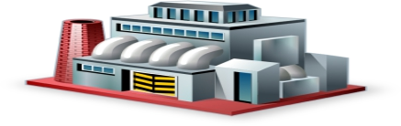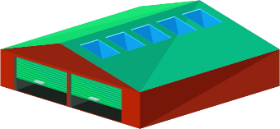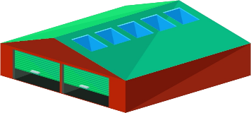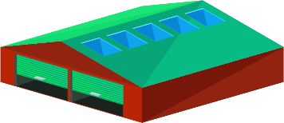

Company

Retailer

Agent

stores

Wholesaler

Sub-Agent

End consumer

*Figure 1* *Work flow of current system*

## Users of the current system

There are many role players or actors in the existing system each with different activities undertaken to carry out the process of sales and distribution of Beer Company. Major actors and activities that are carried out during the sales and distribution process of BGI Beer Company are:

**Beer Company:** Are players that are responsible for producing, selling, and distributing their beer products.

**Agent** Are players in the existing system buy products from the Beer Company and sell them to wholesalers or retailers. In our case study, there is one Agent in Adama that covers the East Shewa Region distributing products in Adama, Bekoji, and Asela. On the other hand, there are six major agents in the BGI Beer Company of the Hawassa Branch. In short**,** Agent is a sales Specialist for the producer, purchasing agent or buyer provides market information anticipate wants, interprets consumers’ needs, Subdivides large quantities of a product, promotes producers’ products, stores product, and creates assortments. Some other functions of an agent include transportation of products; negotiating with customers to provide financing, share risk with Beer companies.

**Sub-Agents:** they work in the same way as Agents to distribute products but they get the products to form Agents, not from the company. They deal with Agents to distribute beer in areas where the Agent is not able to address and they operate on the agreement made.

**Wholesalers:** Are players that buy products from agents and distribute the product to the retailer**.** In ST George Beer Company**,** the wholesaler will typically buy goods directly from the agents, but could also buy from a reseller.

**Retailers**: Are players that buy products from wholesalers. Although, retailers could also buy products directly from agents.

**Distributors:** Are players that buy Beer products from agents or wholesalers and resell them to retailers or direct to the end-user or customers. Distributors are different from wholesalers and retailers in such a way that most distributors provide strong labor and cash support to the supplier or manufacturer’s promotional efforts. They usually maintain exclusive buying agreements that limit the number of participants or enable distributors to cover a certain territory.

**Drivers:** these are hired by agents or sub-agents for distributing the beers with vehicles (trucks).

**Laborers:** are workers hired for their manual skills of loading and unloading beer crates from vehicles.

**Cashiers:** are bookkeepers that handle and report the payments and receipts made by customers.

**Sales Promoters(of Agents):** they do the work of finding new outlets and customers in newer areas or newly opened outlets for sales.

**Customers (Final consumers):** A final consumer is the last point in a distribution channel. The final consumer can reach directly or through multiple levels of channels (agents-> Wholesalers-> retailer -> Consumers) in between the manufacturer and the end consumer. The final consumer can be a Human being or person who usually drinks beer products, Hotels, Glossaries, Restaurants, Café, shops, Supermarkets, Companies, and more…

**Promoters**: Other than other types of players, promoters are a type of actors that usually check if the product sold from Beer Company reached the final consumers. Promotors contact both sales agents and customers to easily track the distribution process and report to the beer company when there is a meeting. Promoters are the highest-paid employees in ST George Beer Company since the workload is relatively higher. Some functions of promoters include:

* Make multiple outbound calls to potential customers
* Deliver customized, targeted sales strategies
* Meet all quotas for inside and outside sales
* Share information about company/product by following sales scripts
* Facilitate future sales
* Answer potential customer questions and follow-up call questions
* Close sales and lead customers through the purchasing process
* Understand customer needs and offer solutions and support
* Maintain a record of calls through a computerized system
* Research potential leads from business directories, web searches, or digital resources
* Work with sales team to close sales

**Finance administrators** Are a type of player that is mainly responsible to administer the financial progress when sell made between the Beer Company and agent. Other responsibilities of finance administrators include:

* Develop and maintain financial analysis and reporting activities for Beer Company.
* Send reports to the main branch of the company, which is currently located in Addis Ababa- Ethiopia.
* Prepare financial reports and account reconciliation reports according to company policies periodically.
* Prepare tax documents for timely filing of company tax.
* Prepare and adjust finance journal entries as required.
* Assist in managing account payable and receivable activities.
* Support the annual financial audit processes through the preparation of standard reports as well as other custom reports as requested.
* Coordinate with finance and HR teams in the preparation of financial reports and statements.
* Administer all payroll activities as well as oversee vendor payments etc.
* Reconcile monthly general ledger balance, invoices, and credit card statements.
* Maintain all financial records and files as per the company policies.
* Assist in setting and managing budgets.
* Identify and resolve invoicing issues, accounting discrepancies, and other financial-related issues.
* Manage all bill payments and customer invoicing as per the deadlines.
* Streamline processes and procedures for improving the operational efficiency of financial reporting and budgeting systems.

**Sales managers** Are the type of actors that are responsible for leading and guiding a team of sales people in an organization. They set sales goals & quotas, build a sales plan, analyze data, assign sales training and sales territories, mentor the members of /her sales team, and are involved in the hiring and firing process. Sales managers play a key role in providing good sales and distribution processes in resolving customer complaints regarding sales and service, preparing budgets and approving budget expenditures, monitoring customer preferences to determine the focus of the sales effort, analyzing sales statistics, and planning and coordinating training programs for sales staff.

## Drawback of the current system

When we try to study the existing sales and distribution system of BGI Beer Company, we have seen those things as problems that need to be improved. Major problems are already justified in the Statement of the problem in chapter one and a few additional problems include:

* + - The manufacturer must put out time and effort to monitor the activities of distributors.
    - There is always the possibility of conflicting sales efforts.
    - Absence of a well-integrated and comprehensive approach to product availability and distribution coverage.
    - Poor announcements to consumers when new products are released.
    - Improper management of sales and distribution mechanisms.
    - Customers might not get enough information about what is been produced and how much is produced.
    - Data collection of the distribution progress is manual and time-consuming, often causing errors and delays in reporting.
    - Difficult data management and delays in data aggregations made actionable data analysis difficult.

## Business rule

There is a various list of rules when controlling sales and distribution in the existing system:

* + - Agents should have a strong agreement to buy products from the company.
    - The agreement paper of agents and the company should be approved by the Head office of the company, which is located in Addis Ababa.
* Agents will buy products from beer companies every day, once in two days or once a week

according to their distance from the Company. If the agent failed to buy the product from the Beer Company within that day, promoters will call the agent and ask them why did not they buy products and they report the reason to the staff members of the companies.

* Customers like Hotels, Restaurants, and Groceries make a strong agreement with the companies.
* Customers that are registered in Beer companies are offered a lot of materials for free like tables, chairs, draft machines, umbrellas, towers, and more.
* If the registered customers stop their business, they should return the materials to the Beer Company.
* If the registered companies lost or damage the item offered from Beer Companies, they should pay the money according to the agreement.

# Chapter 3: Proposed System

## 3.1 Overview

The involvement of different beer companies in the beer industry and the increase in the consumption of beer is a significant issue for beer companies. BGI, being a huge company follows the traditional way of manual mechanism to sell and distribute its products. Besides the main issue is how the product reaches the end-user. These issues lead beer companies to think about how to distribute and sell their product

The system we are going to develop will provide a well-organized beer sales and distribution system that helps companies to manage their products, get reports, track their products, get online payments, and track transactions. The system is going to be web-based so the users can access it through the internet regardless of their location.

## 3.2 Functional

**requirements**

* + - Admin adds new distributors(agents).
    - Customers able to register in the system through the web-application.
    - Customers and agents can order products and make online payment.
    - Agents and the company are able to generate report of transactions. The company schedules the agent orders

## 3.3 Non-functional requirement

* + - Usability: Our system should be user friendly and attractive for users**.**
    - Performance: Our system should perform tasks as fast as possible, it should be safe

to use, it should be precise when performing activities, should be available and

should be able to be scalable when new beer companies and new customers registered to the system.

* + - Security: Our system should be able to provide security for all system users

regarding privacy, authentication/authorization when login and more…

* + - Interface: Our project interface should be able to contain all the activities required to be performed by the user

## 3.4 System model

System modeling is the process of developing abstract models of a system, with each model presenting a different view or perspective of that system. It is about representing a system using some kind of graphical notation, which is now almost always based on notations in the UML. Models help the analyst to understand the functionality of the system; they are used to communicate with customers.

### Scenarios

Since a scenario is a tool that is used during requirement analysis to describe a speciﬁc use of a proposed system. Using this tool, we will illustrate some interaction of our proposed system.

**Scenario 1:** Signup for customers and distributor Actor: customer, distributor

Entry condition: Internet connection

Flow of event:1. open the web app

* 1. click sign up
  2. select customer/distributor
  3. fill required information
  4. click Register button

**Scenario 2:** Login for customer & distributors Entry condition: Internet connection

Have to be a registered user Actors: customer, distributors

Flow of event: 1. Open login page

1. Select customer/distributor
2. fill username & password 4, Click login button

**Scenario 3:** . Place order for product Actor: customer

Entry condition: Internet connection

Should login to the system first Flow of event: 1, click Make order

2,choose amount

3, Choose payment option 4, Make payment

**Scenario 4:** . Send delivery status Actor: customer

Entry condition: Internet connection

Should log in to system should make order first

Flow of event: 1, Go to order history

2, Click on the specific order

3, Then click Received/ Not Received

**Scenario 5:** Rate distributors Actor: customer

Entry condition: Internet connection

Should send delivery status first

Flow of event: 1, Rating box appears immediately after sending

delivery status

2, Choose the desired rating number 3, submit rating

**Scenario 6:** . View Request order Actor: distributor

Entry condition: Internet connection

Have to login to the system flow of events: 1, Click New orders Menu

2, system displays list of assigned orders

**Scenario 7:** Make order Actor: distributor

Entry condition: Internet connection

Have to be a registered user Should login to the system

flow of events: 1, Click on Order products menu

2, Choose amount to be ordered 3, choose payment option

4, Make payment

**Scenario 8:** View delivery status Actor: distributor

Entry condition: Internet connection

Have to be a registered user

Flow of event: 1, Go to view Assigned Orders Menu

2, Check delivery status whether pending, recieved or not recieved

**Scenario 9:** Register driver Actor: distributor

Entry condition: Internet connection

Have to be a registered user Flow of event: 1, Click Add Driver Menu

2, Fill in the required form 3, click Add Driver

**Scenario 10:** Assign Order for customer Actor: distributor

Entry condition: Internet connection

Have to be a registered user Flow of event: 1, Go to New orders Menu

2, Select specific order 3, Assign driver

4, Give order detailes to driver

**Scenario 11:** Admin Login Actor: company(admin)

Entry condition: Internet connection Flow of event: 1, Goto webapp

2, Fill in username and password 3, Click login buttton

**Scenario 12:** Add Distributor Actor: admin(company)

Entry condition: Internet connection

should login to the system first

Flow of event: 1, Click on Manage distributor Menu

2, Select Register Distributor Option

3, Fill required information in to the form 4, Click Add button

**Scenario 13:** Generate report Actor: admin(company)

Entry condition: Internet connection

Login first

Flow of event: 1, Click Generate Report Menu

2, Select distributor

3, Select time range for report 4, Click Genarate button

**Scenario 14:** , Post advertisement Actor: admin(company)

Entry condition: Internet connection

Login first

Flow of event : 1, Click Post Advertisement Menu

2, Fill the Advertisement form 3, Click Post button

**Scenario 15:** , Assign order for distributor Actor: sales and fanicial admin Entry condition: Internet connection

Login first

Flow of event: 1, Go to new orders

2, select specific order 3, Approve and schedule

4, Send slip and exit permision for agent

5, Send detail to store manager of selected industry

## **3.4.2 Use case model**

### Actor identification

Administrator

* + - * Login
      * Add distributor
      * Generate report
      * Post advertisement
      * Manage account
      * Logout

Distributor

* Login
* View assign order
* View delivery status
* Register driver
* Assign Driver
* Make oder
* Manage account
* Logout

Customer

* + Signup/login
  + Place order
  + Send delivery status
  + Rate distributors
  + Manage account
  + Logout

### 3.4.3 Use case Description

|  |  |
| --- | --- |
| Usecase name | Login |
| Usecase ID | 1 |
| Use case description | System users use this to login into the system |
| Actor | Admin, distributor, customer |
| Pre-condition | The user must have a username and password and internet connectoin should be set up first |

|  |  |
| --- | --- |
| Post-conditon | Login to the actor page/leave from page |
| Main flow | * Actor open the webapp * the system display login form * select user type * user fills correct username and password * click login button * the system direct to the user page |
| Exceptional flow | System displays warning message and asks user to reenter correct data if the user fills invalid username and password. |

*Table 4* *Usecase description login*

|  |  |
| --- | --- |
| Usecase name | Add distributor |
| Usecase ID | 2 |
| Use case description | The system will allow administrator to add/register new distributor to the system |
| Actor | Admin |
| Pre-condition | Strong agreement should be made between the administrator and the distributor. |
| Post-conditon | New distributor is registered to the system |
| Main flow | * The administrator will click on add distributor menu * the system will display form to add new distributors * The administtator will fill the required fields * the administrator will click Add distributor button * the system validates the input and register the distributor to the   system |
| Exceptional flow | if the administrator fills wrong attributes the system will display error message and directs back to the top of the main flow of action |

*Table 5* *Usecase description Add distributor*

|  |  |
| --- | --- |
| Usecase name | Generate Report |
| Usecase ID | 3 |
| Use case description | Administrator(company) uses this to see the reports of the company’s sales and distribution process |
| Actor | Admin |
| Pre-condition | Admin must login to the system  There should be list of transction made between between certain period of time |
| Post-conditon | Printable formatted report will be generated |
| Main flow | * Admin clicks on Report Menu * The system will show the form to make report generation * The adminidtrator will select time duration and other types of transaction attributes and click on generate report * the system will generate report in such a way that it is printable |
| Exceptional flow | - |

*Table 6* *Usecase description Generate report*

|  |  |
| --- | --- |
| Usecase name | Post advertisement |
| Usecase ID | 4 |
| Use case description | Administrator use this to post news or advertisements |
| Actor | Admin(company) |
| Pre-condition | Admin must login to the system's |
| Post-conditon | News and Advertisements will be posted to system |

|  |  |
| --- | --- |
| Main flow | * Admin click on post advertisements * system will display form to post advertisements * admin will fill required fields and click on post * the system will show succes message |

*Table 7* *Usecase description Post advertisement*

|  |  |
| --- | --- |
| Usecase name | View request order |
| Usecase ID | 5 |
| Use case description | The system will allow distributor to view assigned order |
| Actor | Distributor |
| Pre-condition | Distributor must first login to the system |
| Post-conditon | The distributor can view the assigned order |
| Main flow | * The distributor will click on view assigned order menu * the system will display the list of order that have been assigned |
| Exceptional flow | If there is no assigned order the distributor must assign order |

*Table 8* *Usecase description View Request order*

|  |  |
| --- | --- |
| Usecase name | View delivery status |

|  |  |
| --- | --- |
| Usecase ID | 6 |
| Use case description | Distributor uses this to view delivery status of the product to the customer |
| Actor | Distributor |
| Pre-condition | Distributor must login to the system  customer must send delivery status of products. |
| Post-conditon | System displays dielivery status of products. |
| Main flow | * Distributor click on Assigned order menu * System will show list of requested orders * Distributor will choose specific order and click in it * the system will display details of the order request and deliery status of the product. |
| Exceptional flow | If one of the delivery status is negative(not delivered), distributor immediately contacts the driver assigned to that specific order and checks on the literal status. |

*Table 9* *Usecase description View Delivery Status*

|  |  |
| --- | --- |
| Usecase name | Register driver |
| Usecase ID | 7 |
| Use case description | The distributoruses this to add new driver to the system |
| Actor | Distributor |
| Pre-condition | The distributor must login to the sysem first The Driver should provide required licences  Strong agreement should be made between the distributor and the driver |
| Post-conditon | A new driver is registered/added to the system |

|  |  |
| --- | --- |
| Main flow | * Distributor clicks Add driver menu * The system displays form to add driver * The distributor fills in the fields with the required information * The distributor clicks on add driver button * The system displays success message |
| Exceptional flow | if the Distributor fills wrong attributes the system will display error message and directs back to the top of the main flow of action |

*Table 10* *Usecase description Register driver*

|  |  |
| --- | --- |
| Usecase name | Assign Order |
| Usecase ID | 8 |
| Use case description | Distributor uses this to assign a driver to a specific order request of customer in a particular location |
| Actor | Distributor |
| Pre-condition | Distributor must login to the system  customer must send delivery status of products. |
| Post-conditon | System displays dielivery status of products. |
| Main flow | * Distributor click on New order menu * System will show list of requested orders * Distributor will choose specific order and click in it * the system will display details of the order request * distributor assignes a driver to the request and gives the order   details to the driver |
| Exceptional flow | If one of the delivery status is negative(not delivered), distributor immediately contacts the driver assigned to that specific order and checks on the literal status. |

*Table 11* *Usecase description Assign order*

|  |  |
| --- | --- |
| Usecase name | Make order |
| Usecase ID | 9 |
| Use case description | Distributor uses this to order for product when it is out of stoke from beer company |
| Actor | Distributor |
| Pre-condition | Distributor must login to the system |
| Post-conditon | Distributor gets store refiil |
| Main flow | * Distributor click on Order products menu * System displays form to place product order * Distributor fills amount to be order * Distributor then chooses payment option * Distributor make payment and clicks confirm * The system displays success message |
| Exceptional flow | If the Distributor fills wrong attributes the system will display error message and directs back to the top of the main flow of action |

*Table 12* *Usecase description Make order*

|  |  |
| --- | --- |
| Usecase name | Place order |
| Usecase ID | 10 |
| Use case description | Customer uses this to order product from distributors. |
| Actor | Customer |
| Pre-condition | Customer must login to the system |

|  |  |
| --- | --- |
| Post-conditon | Customer places order to the system |
| Main flow | * Customer clicks Place order Menu * Customer searches for the closest distributor and selects one * The system will display product order form * Customer places order request in the required field and clicks   order product button   * The system will ask the customer if he/she is sure to make the order * the customer will place confirmation * the system will will show success message to the customer |
| Exceptional flow | If the customer fills wrong input, the system will show error message and goes back to main flow. |

*Table 13* *Usecase description Place order*

|  |  |
| --- | --- |
| Usecase name | Send Delivery status |
| Usecase ID | 11 |
| Use case description | Customers use this to send positive or negative delivery status to the distributor |
| Actor | Customer |
| Pre-condition | Customer must login to the system  The estimated delivery time must exceed |
| Post-conditon | Delivery status will be sent to the distributor |
| Main flow | * Customer clickss on “Order history” menu * The system displays list of order requests made by the customer * Customer will choose specific order to send delivery status * Thes system will check if the estimated time of delivery has   passed and shows form   * The customer will choose either positive or negative status and click on send * the system will show success message that the status is sent to the distributor |

|  |  |
| --- | --- |
| Exceptional flow | If the customer clicks on the order which the time did not pass, the system will not send delivery status to the distributor. |

*Table 14* *Usecase description Send delivery status*

|  |  |
| --- | --- |
| Usecase name | Rate Distributor |
| Usecase ID | 12 |
| Use case description | Customers use this to give ratings to the distributors according to their satisfaction |
| Actor | customer |
| Pre-condition | Customers must login to the system  The customer must send delivery status first |
| Post-conditon | The rating will be sent to the admin |
| Main flow | * The customer clicks on my order requests * the system displays list of order requests made * The customer clicks on the assigned distributor and places the   rating   * The system show success message that the rating is successfully sent to the distributor |

*Table 15* *Usecase description Rate distributor*

|  |  |
| --- | --- |
| Usecase name | Logout |
| Usecase ID | 13 |
| Use case description | System user uses this to logout from the system |

|  |  |
| --- | --- |
| Actor | Admin,distributor, customer |
| Pre-condition | User must be logged in to the system first |
| Post-conditon | The user will leave/logout form the system |
| Main flow | * System user clicks logout button/link * The system will show dialogue to make sure that the user wants to   logout   * the user clicks Yes to confirm he/she wants to logout * The system will logout the user |
| Exceptional flow | If the user clicks no the system will keep the user logged in to the system |

*Table 16* *Usecase description Logout*

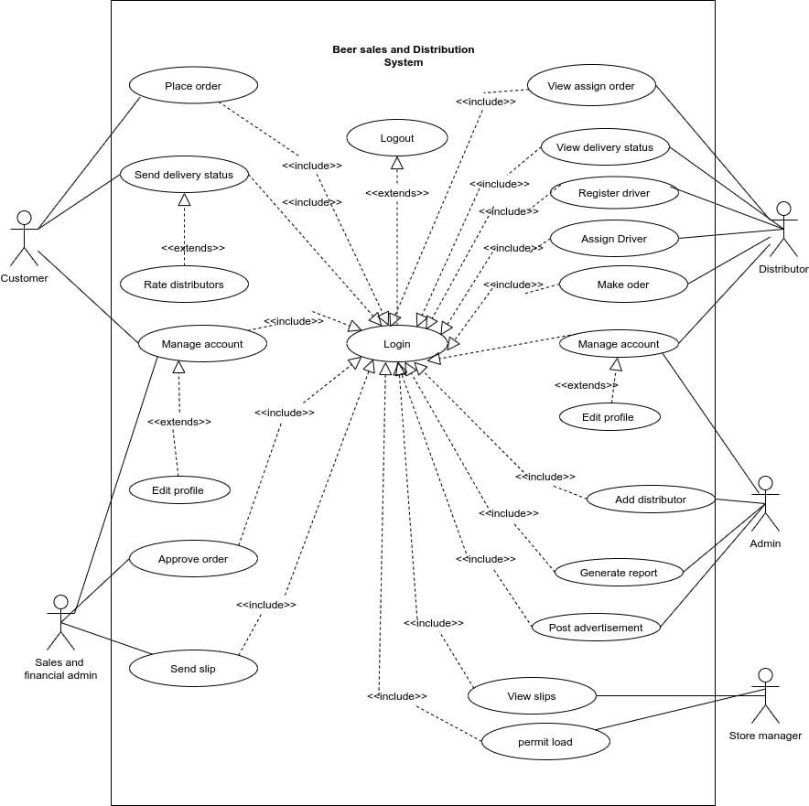

*Figure 2* *Uscase diagram*

## 3.5 Object model

An object model is a logical interface, software or system that is modeled through the use of object-oriented techniques. It enables the creation of an architectural software or system model prior to development or programming.

### Data dictionary

|  |  |  |  |
| --- | --- | --- | --- |
| **Class** | **Attribute** | **Operation** | **Description** |
| Agent | Username, password,id region,phone, email, | Login()  Add customer()  Add driver()  Assign order()  Make order() | Allows the agent/distributor to login into the system and perform the operations enlisted |
| Store manager | Username, password, phone, name, email | View slips()  Permit load() | Allows store manager to view slips and permit/allow the agent to load |
| Admin | Username, id, password, name, phone, address, email | Add agent()  Post advertisements()  Generate report()  Create sales admins() store managers() | Allow the admin of the company to add agents, store managers, sales admins and generate reports as well as post advertisements. |
| Advertisement | Data, time |  | Allow the admin to advertise |
| Agent order | Order _id, product amount, Total price |  | Allow the agent to make order for products. |
| Coordinator | Id, name, phone, email, region |  |  |
| Region | Region_id, Region_name, Geographical location,  Regional_manager,  Regional_coordinator |  |  |
| Sale and finance admin | Username, id password, phone, email | Approve order()  Send slip() | Allow sales admin to approve orders and send slips to store manager and agents. |
| Transaction | Order_id, transaction_id |  |  |
| Product | Product_id, product_type, product_availability |  | Allow agents to see detail information about product |
| Company store | Store_id, storemanager_id, product_id |  |  |
| Customer | Username, password, id, email, location, agent_id | Sign up()  Login()  Place order()  Rate distributor() | Allow the customer to register, login, make order and rate distributor(agent) |
| Driver | Name, Driver_id, agent_id, |  |  |
| Customer order | Customer_id, transaction_id agent_id, quantity, product_type |  |  |

Table 17 data dictionary

### Class diagram

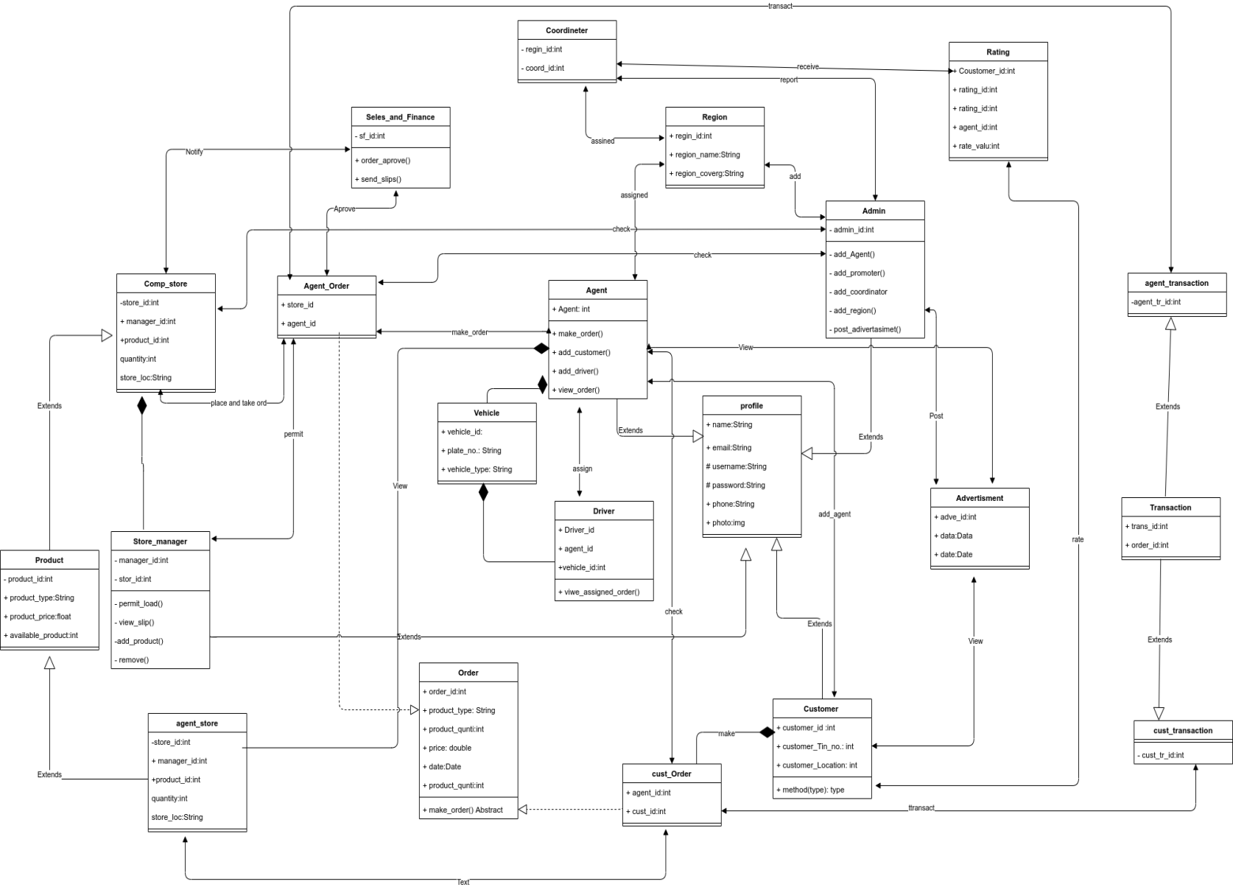

Figure 3 *class diagram*

## 3.5.3 Dynamic model

### 3.5.4 Sequence diagram

Under this topic, we will describe our system using The Sequence Diagram. A sequence diagram simply depicts the interaction between objects in a sequential order i.e. the order in which these interactions take place. We can also use the terms event diagrams or event scenarios to refer to a sequence diagram. Sequence diagrams describe how and in what order the objects in a system function. It shows, as parallel vertical lines (lifelines), different processes or objects that live simultaneously, and, as horizontal arrows, the messages exchanged between them, in the order in which they occur. This allows the specification of simple runtime scenarios in a graphical manner.

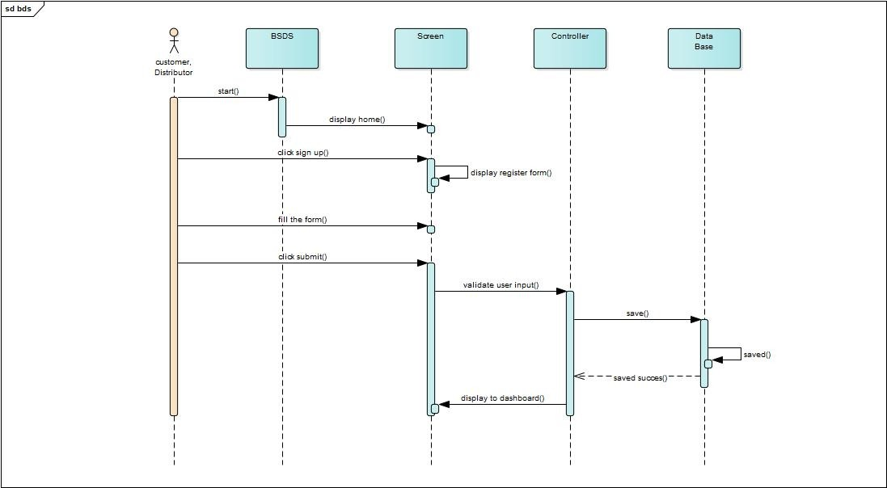

*Figure 4* *Sequence diagram Registration*

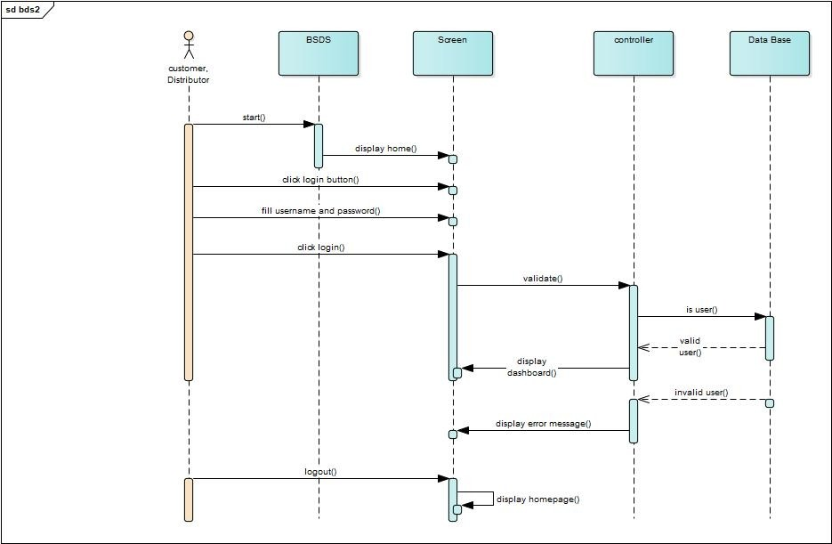

*Figure 5* *Sequence diagram Login*

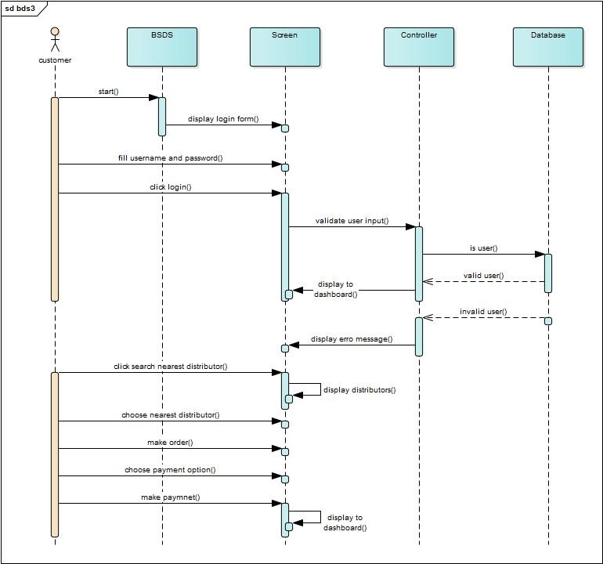

*Figure 6* *Sequence diagram for Customer place order*

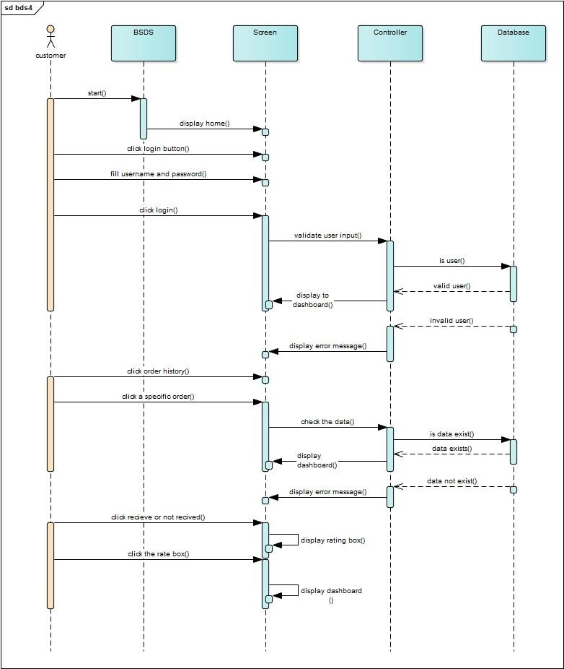

*Figure 7* *Sequence diagram for send delivery status*

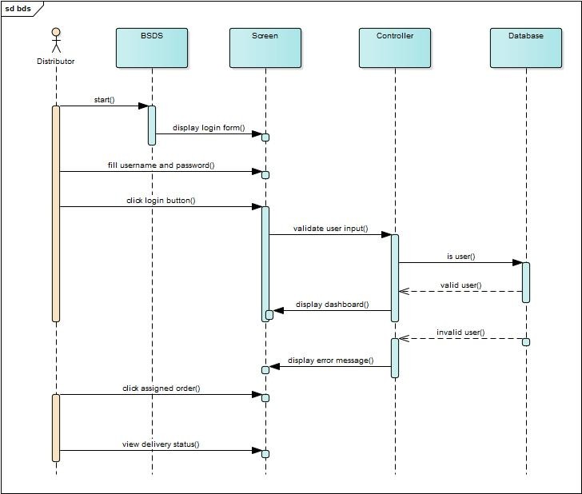

*Figure 8* *Sequence diagram for view delivery status*

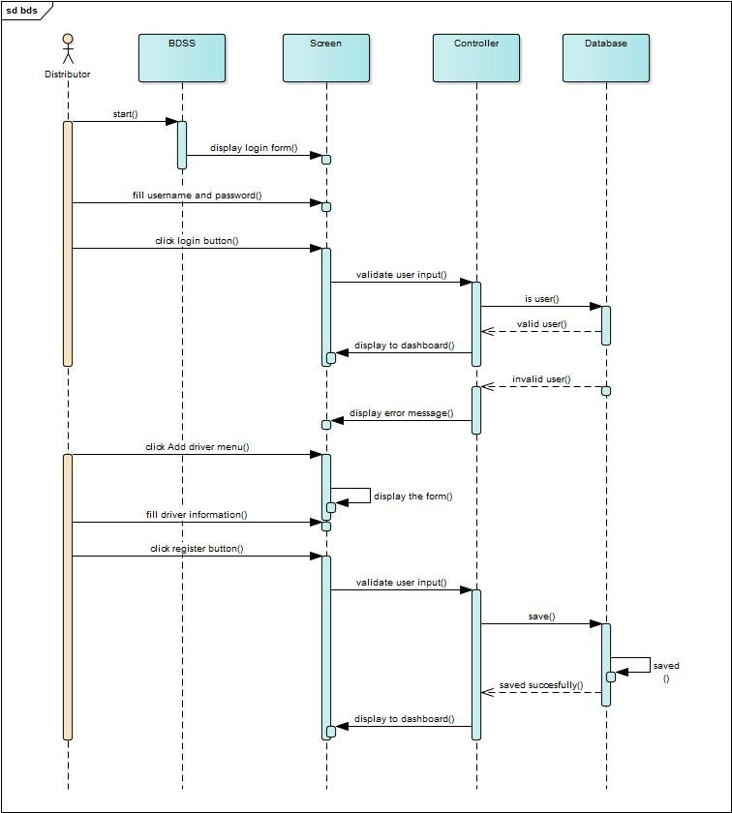

*Figure 9* *Sequence diagram for register driver*

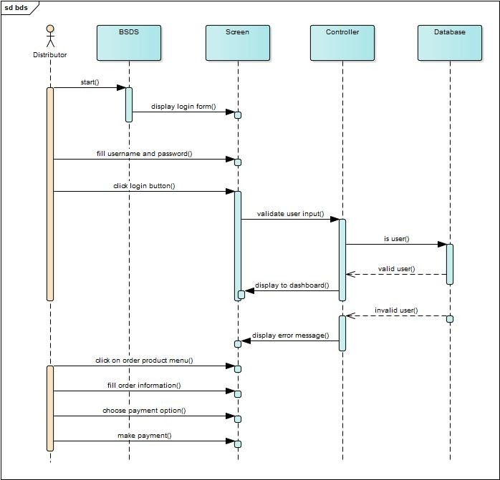

*Figure 10* *Sequence diagram for distributator to make order*

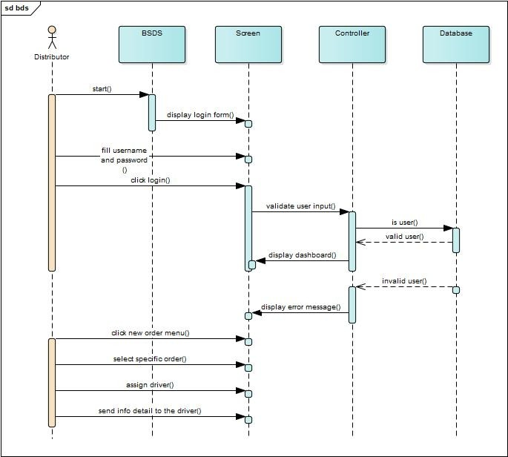

*Figure 11* *Sequence diagram for distributor to assign order*

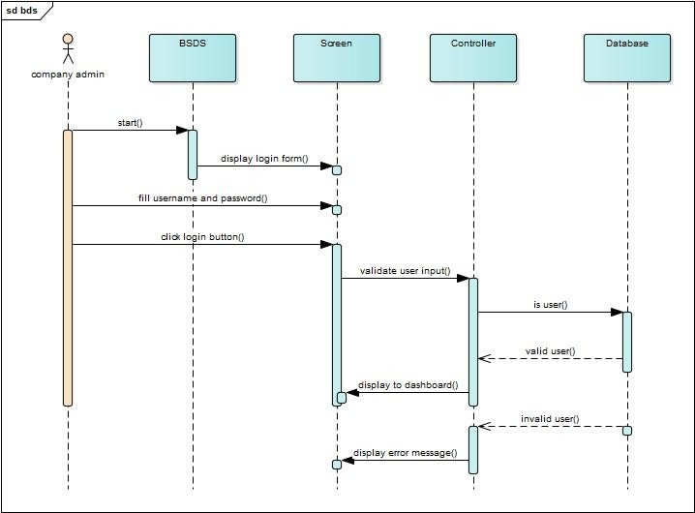

*Figure 12* *Sequence diagram for company login*

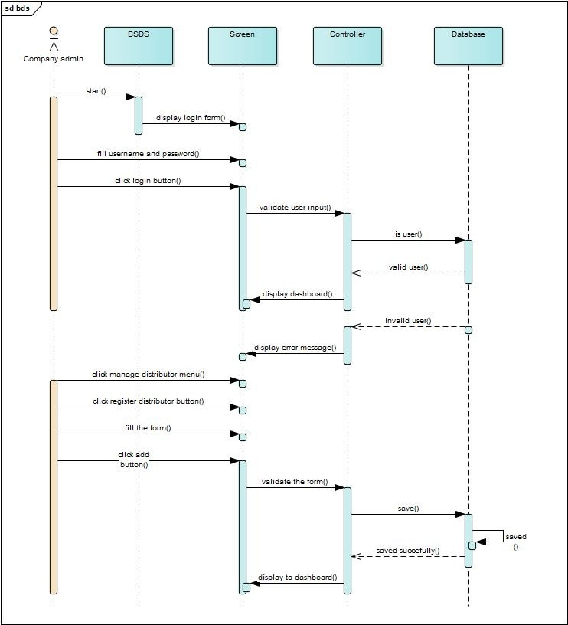

*Figure 13* *Sequence diagram for company add distributor*

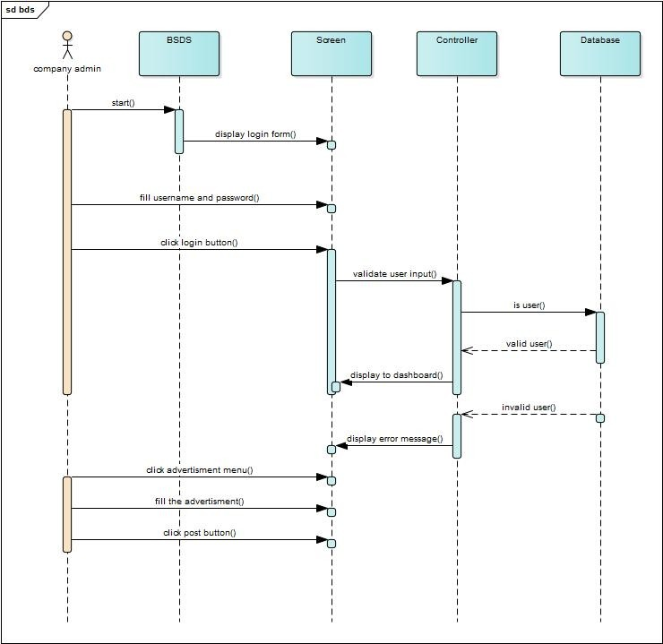

*Figure 14* *Sequence diagram for company to post for advertisment*

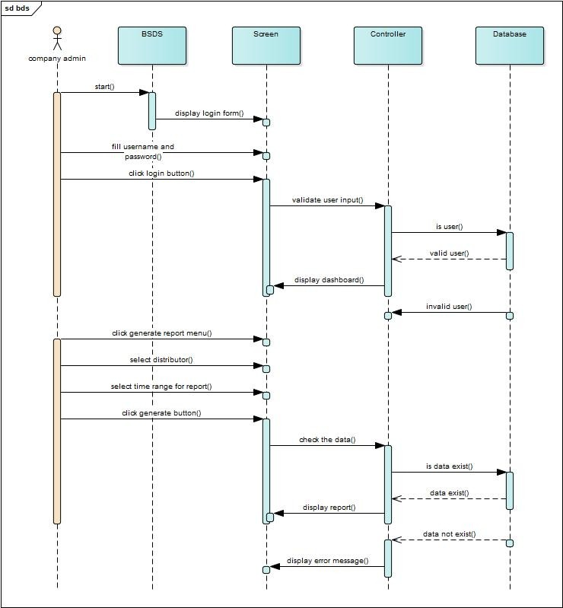

*Figure 15* *Sequence diagram for company to generate report*

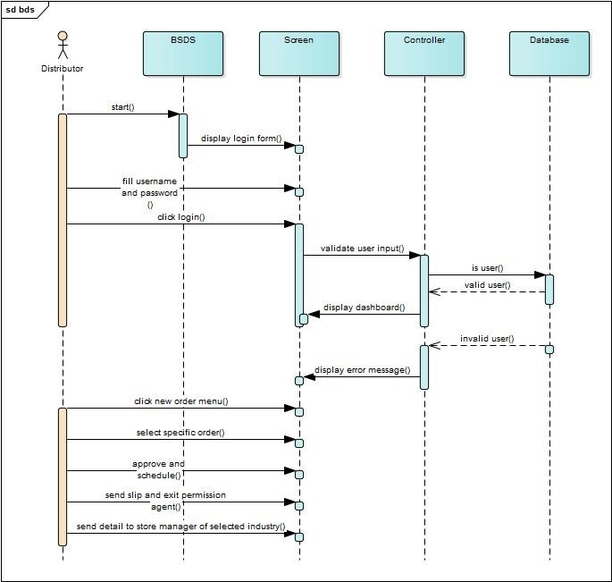

*Figure 16* *Assign order for distributor*

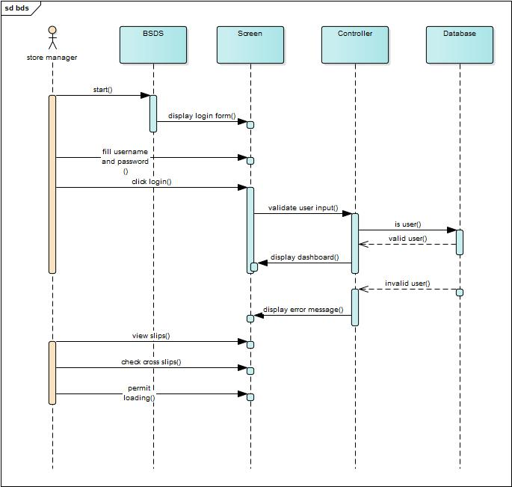

Figure 16 sequence diagram for store manager

### 3.5.5 Activity diagram

Under this topic, we will describe the activities included in our system using the Activity Diagram. An activity diagram is another important diagram in UML to describe the dynamic aspects of the system. An activity diagram is basically a flowchart to represent the flow from one activity to another activity. The activity can be described as an operation of the system. The control flow is drawn from one operation to another

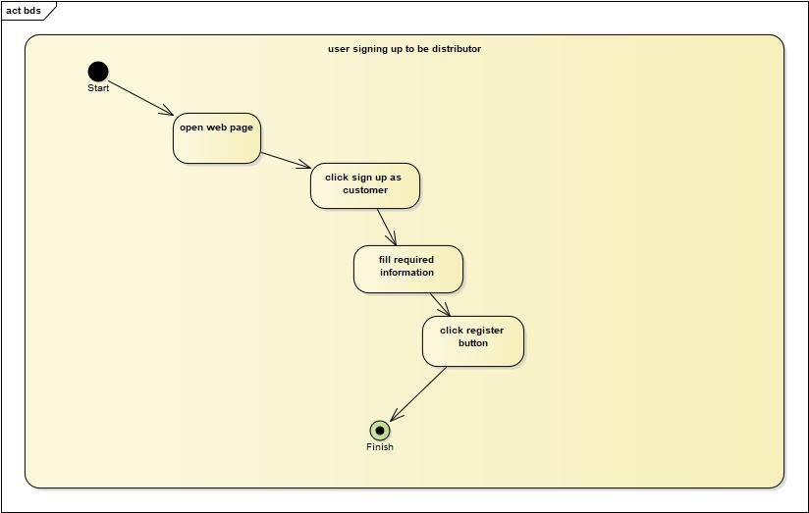

*Figure 17* *User sign up to be a disributor*

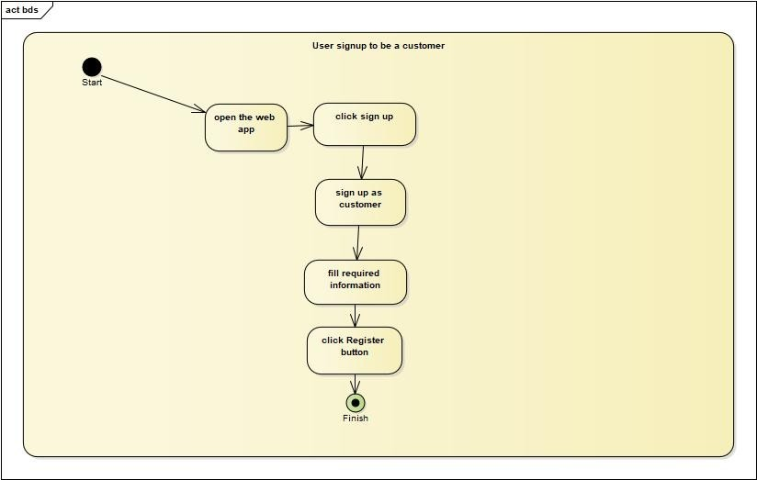

*Figure 18* *user sign up to be a customer*

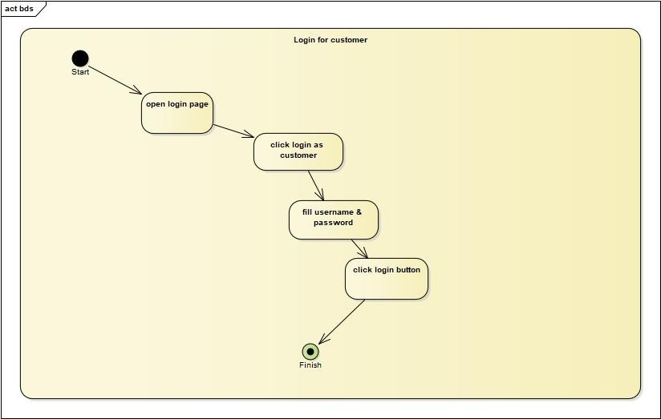

*Figure 19* *user login as customer*

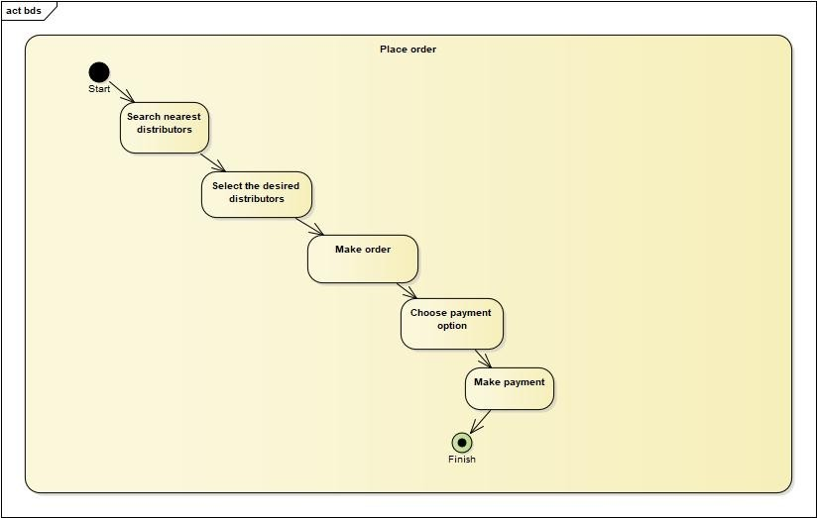

*Figure 20* *user place order*

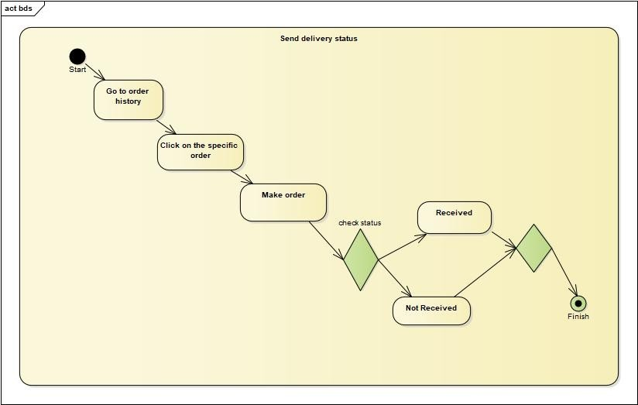

*Figure 21* *sending delivery report*

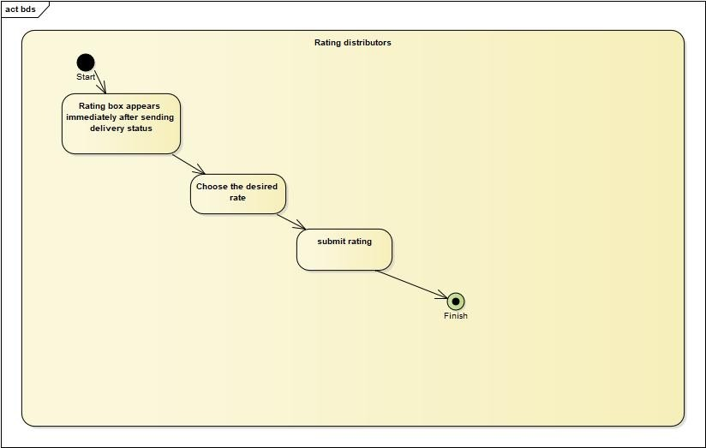

*Figure 22* *user rating distributor*

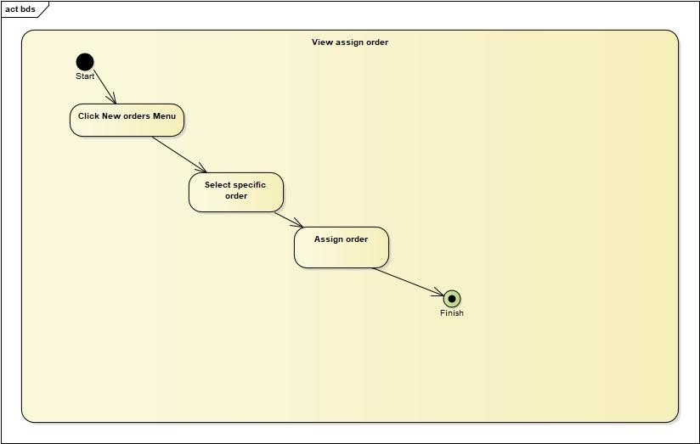

*Figure 23* *viwing assign order*

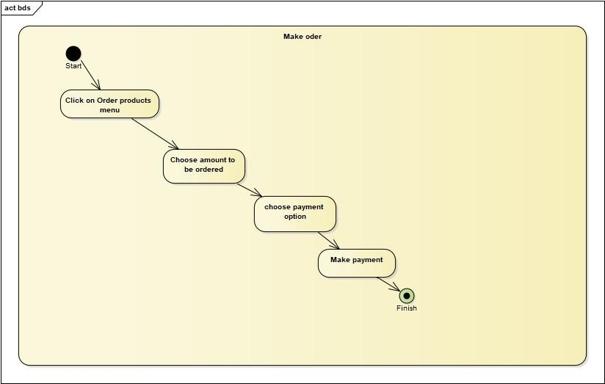

*Figure 24* *user making order*

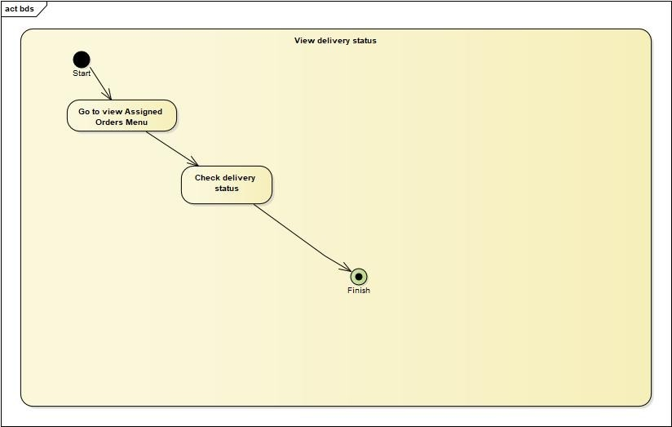

*Figure 25* *user viwing delivery report status*

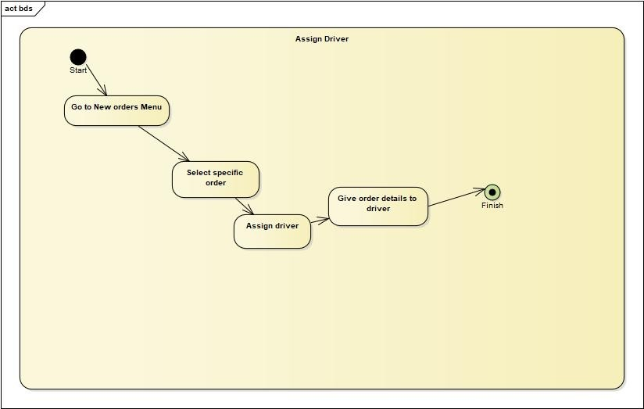

*Figure 26* *assining deriver*

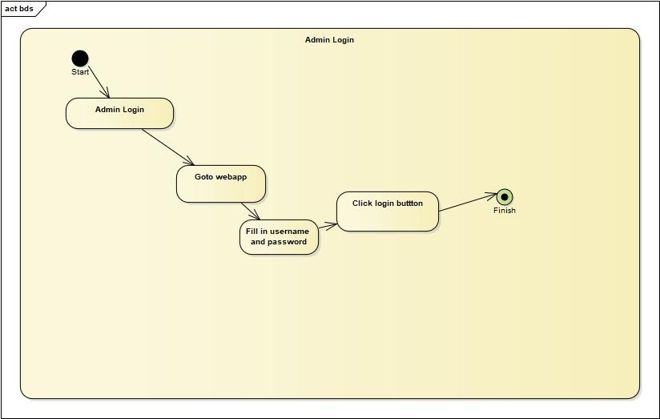

*Figure 27* *Admin login*

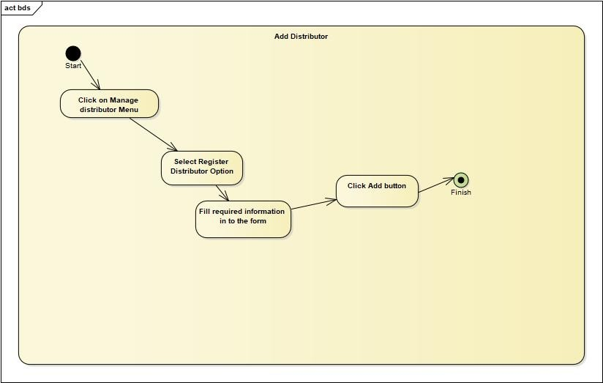

*Figure 28* *Add distributor*

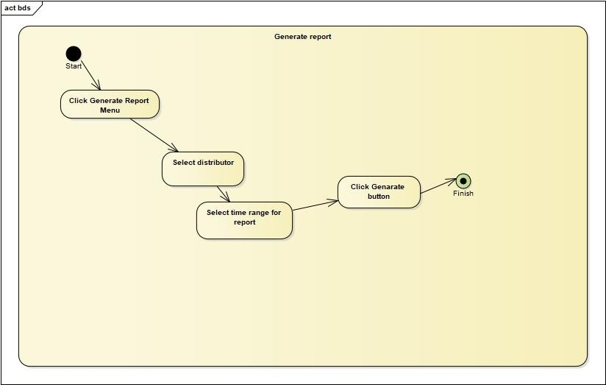

*Figure 29* *report generation*

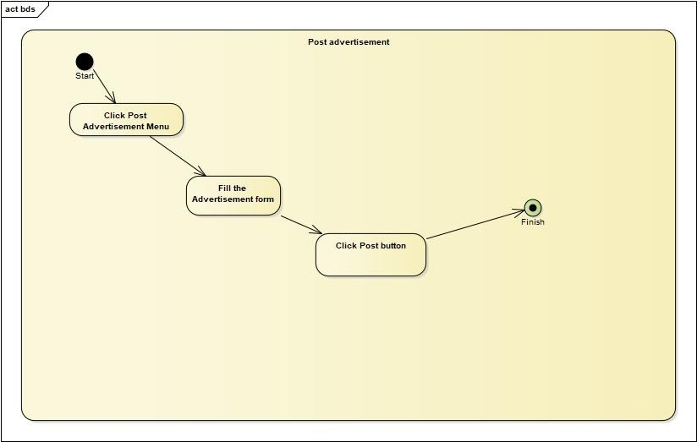

*Figure 30* *Posting Adverstisment*

### 3.5.6 State chart diagram

Here we will be using a state diagram to express the behavior of our system because A Statechart diagram describes a state machine. A state machine can be defined as a machine which defines different states of an object and these states are controlled by external or internal events

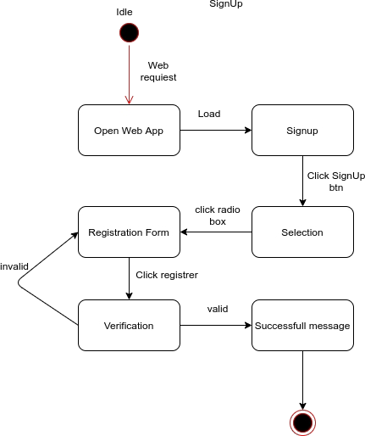

*Figure 31* *State chart diagram for signup*

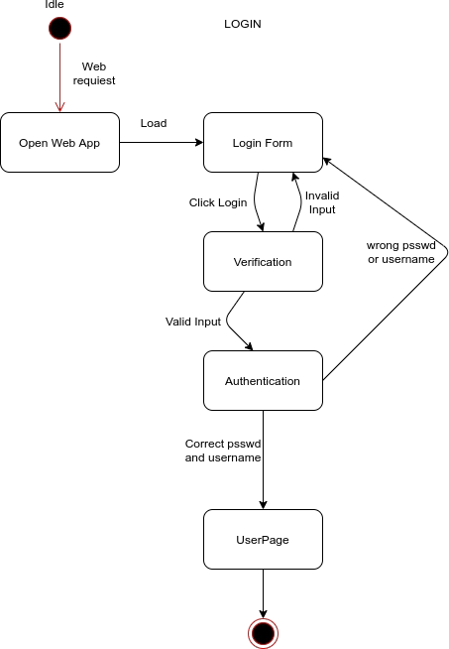

*Figure 32* *State chart diagram for Login*

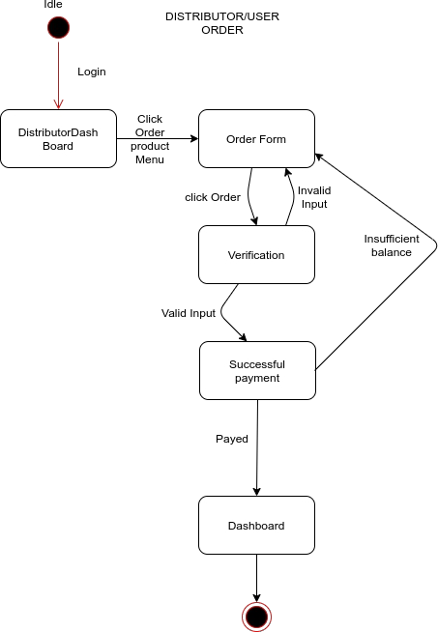

*Figure 33* *State chart diagram for Distributor order*

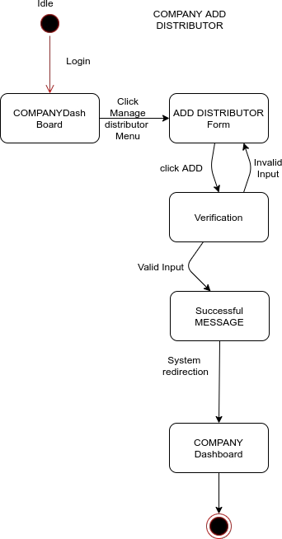

*Figure 34* *State chart diagram to add distributor*

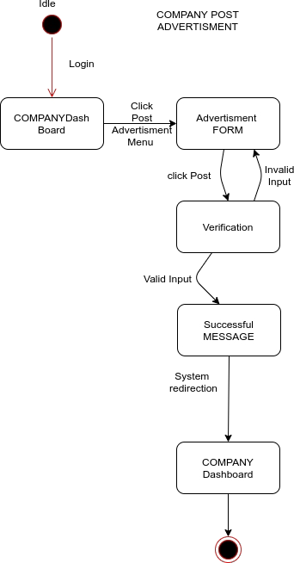

*Figure 35* *State chart diagram to post advertisement*

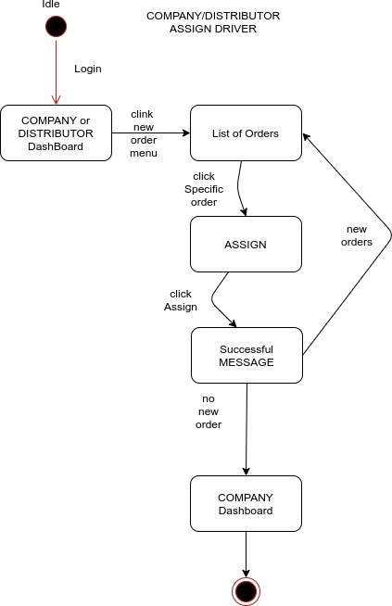

*Figure 36* State chart diagram to assign driver

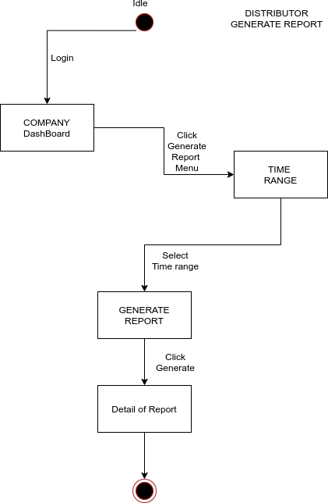

*Figure 37* *State chart diagram to Generate report*

# **4.1 overview**Chapter Four: System Design

This is the System Design document for the beer sales and distribution system. The document includes the design goals, the proposed system Design, and the object design.

### Purpose of the system design

This document describes the design issues of the overall system. It provides the complete Architectural overview of the proposed system. It is intended to capture and express the significant architectural decisions which have been made on the system as well as to obtain the information needed to sell and distribute beer all of the counry.

### Design Goal

The design goals describe the qualities of the system that are derived from the nonfunctional requirements which can lead to decisions of developers. The designing part is very important so as to make the implementation or the coding part very easy. The different types of the system modeling techniques that are used for the implementation of the system such as deployment and component modeling are show in detail. Not only the system modeling techniques but also some system design techniques such as system decomposition design are cover in detail in this phase. These goals can be inferred from the nonfunctional requirements.

These are: -

* + - * Performance
      * Dependability
      * Maintenance
      * End user

**Performance**

In order for the best beer distribution system of to give the user a good service it should meet the following performance criteria.

**Response time**: - Depending on the network connection that the user machine has the system is going to interact and respond to user’s request in a maximum of a second, if the user is just viewing the pages, but if the user’s request requires the processing of the data base, like searching for schedule, is going to take an average of 1-5 seconds of communication latency with the server system. And streaming of trailers is going to have a response time up to 2-4 seconds

**Memory**: -The client system requires an average of 512M megabits of RAM memory to be loaded on a user’s web browser and streaming of trailers require additional memory up to 1 GB. The server system is going to require up to 10 TB of memory to store all the data and other components of the system.

**Dependability**

Beer sales and distribution System should achieve the following dependability characteristics in order to resist crash and be available and reliable.

* **Robustness**: - since the system is a web-based system, that mainly use a menu driven entry there wouldn’t be an input problem by the user side. But for the server side there

might be an error during the process of entering a data. In this time the system will provide an error page and the system will continue without failure or crush.

* **Availability**: - as long as there is an internet connection the system will be available 7 days a week and 24 hours a day.
* **Security**: for official user side the system will provide a user name and password that

will manage their own page according to their level of access.

* **Reliability**: the information provided by the system is as reliable as it is presented on the web page interface, and this is maintained by the persistent database.

### 

**Maintenance**

In time of failure or need modification the system needs to be maintained. To be maintainable the system should meet the following maintenance criteria

* + **Extensibility**: - if it is needed to add new functionality to the system, this must be achieved by only making a separate page and integrate this page with the existing system.
  + **Modifiability**: - if in the system, some functionality requires to be modified, this modification must be done specifically to that function or page without affecting the overall

system organization.

* + **Portability**: - the system is developed to be viewed and retrieved from any web browser regardless of their version and platform it resides in it.
  + **Readability**: - the system code can be viewed by clicking on the current web page and choose “view the source code” option

**End user**

From the user point of view the system should provide the following end user criteria’s so that the system can achieve at least 90% usability by the user

* + Utility: - in order to help the user, to easily understand and interact with the system, the system must provide the following utilities
    - Mouse over tips
    - Keyboard alternative
  + Usability: to enhance the usability of the system, the system should be designed incorporating the following usability concepts
    - Site mapping
    - Consistent page pattern
    - Less overcrowded interface.

**Priorities of the system**

The design goals of beer sales and distribution system are prioritized as follows

|  |  |
| --- | --- |
| Priority | Design goal |
| 1 | End User |
| 2 | Performance |
| 3 | Dependability |
| 4 | Maintenance |

*Table 17* *priority of the system*

## Proposed System Architecture

**Overview**

The proposed system is mainly based on the SRS document that’s already developed and submitted.

It mainly deals with subsystem decomposition – dividing the system into

manageable components. Another major task in system design deals with hardware/software

mapping which deals with which components would be part in which hardware. Yet another aspect of system design deals with persistent data management, which illustrates as to how persistent data (file, database, etc.) are stored and managed and at last Access control will be Presented.

Our system uses a three-tier architecture. A three-tier architecture is a client-server architecture in which the functional process logic, data access, computer data storage , and user interface are developed and maintained as independent modules on separate platforms. A three-tier architecture is a software design pattern and well-established software architecture.

* Client-side: here in the client side Company admin, agent admin, sales and finace admin and customers .
* Server-side: here the web servers to connect the database application are found; meaning that the application logic to perform the application by the client is found in here.
* Database: here the databases that store the information are found.

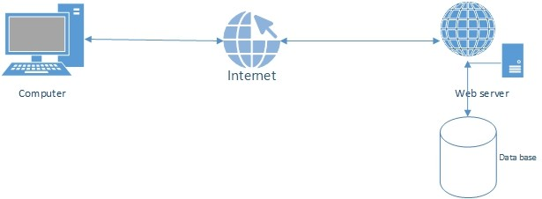

*Figure 38* *system overview*

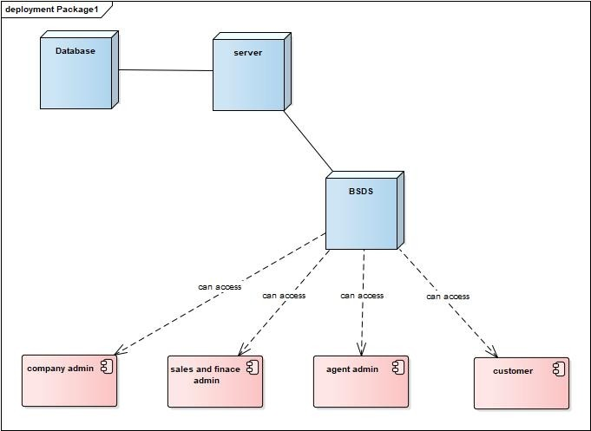

*Figure 39* *client-server architecture for BSDS*

### System Process

The following system process diagram shows an overall process of the system.

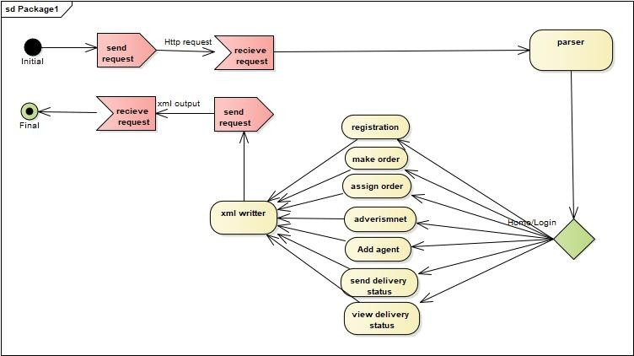

*Figure 40* *complete system process diagram*

### Subsystem Decomposition

Subsystems are a collection of classes, associations, operations, events, and constraints that are closely interrelated with each other. The objects and classes from the object model are the “seeds” for the subsystems. In UML, subsystems are modeled as packages. The system is broken down into four separate subsystems:

Subsystem 1: Company Admin, Subsystem 2: Regional Distributor, Subsystem 3: Sales and Finance administator, Subsystem 4: Customer

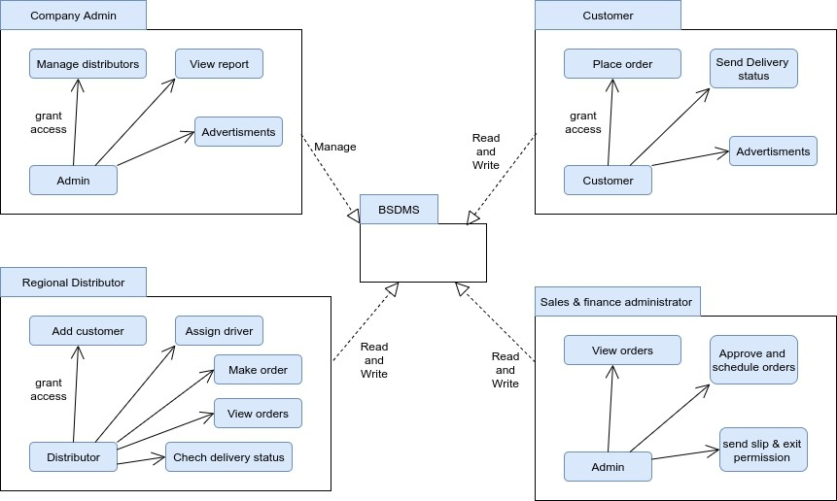

*Figure 41* *subsystem decomposition*

### Hardware / software mapping

The system will have three tiers namely User interface (UI), Web server and Database. The user interface is the means by which the user and a system interact.

Whereas Web server is a program that uses HTTP (Hypertext Transfer Protocol) to serve the files that form Web pages to users, in response to their requests, which are forwarded by their computers' HTTP clients. A database server is a server which houses a database application that provides database services to the system.

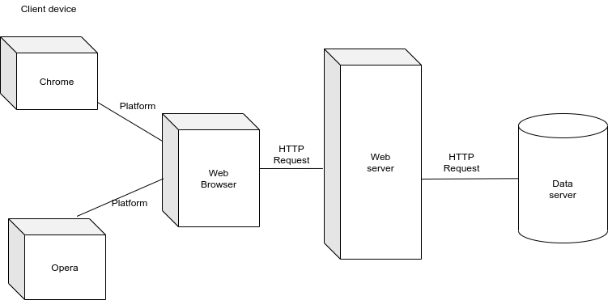

*Figure 42* *Hardware - Software Mapping*

### 4.2.4. Persistent data management

The purpose of this section is to show the mapping of the objects/classes of the system, identified during the analysis stage, in to the corresponding relational

database.

|  |  |  |
| --- | --- | --- |
|  | Key |  |
|  |  |
| Class Mapped Relational Database Table | | |

*Figure 43* *persistent data management model*

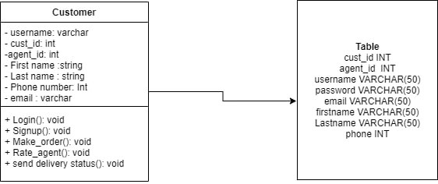

*Figure 44* *object mapping customer*

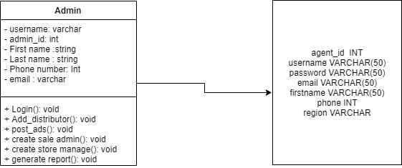

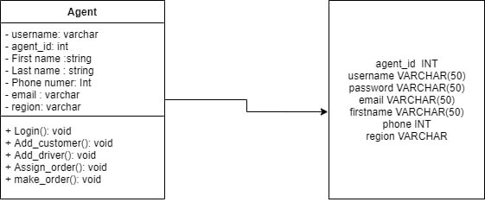*Figure 45* *object mapping admin*

*Figure 46* *object mapping-agent*

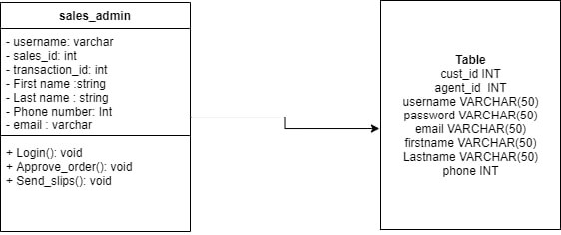

*Figure 47* *object mapping sales and finance admin*

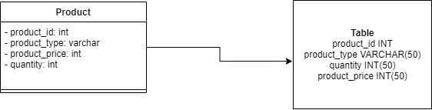

### 

Figure 48 object mapping for products

### 4.2.5 Component diagram

In Unified Modeling Language (UML), a component diagram depicts how components are wired together to form larger components or software systems. They are used to illustrate the structure of arbitrarily complex systems. While other UML diagrams, which describe the functionality of a

system, component diagrams are used to model the components that help make those functionalities. The following component diagram represents a group graph of components connected by dependency relationships.

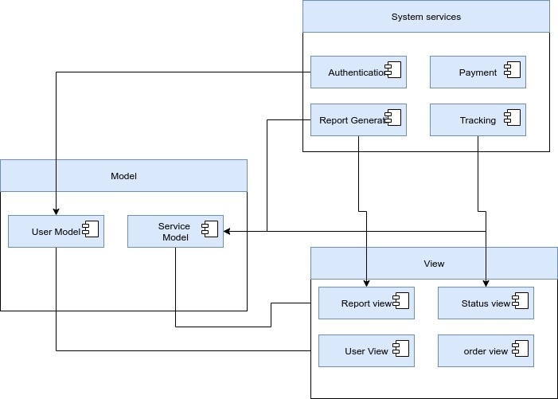

*Figure 48* *component diagram*

### 4.2.6 Database design

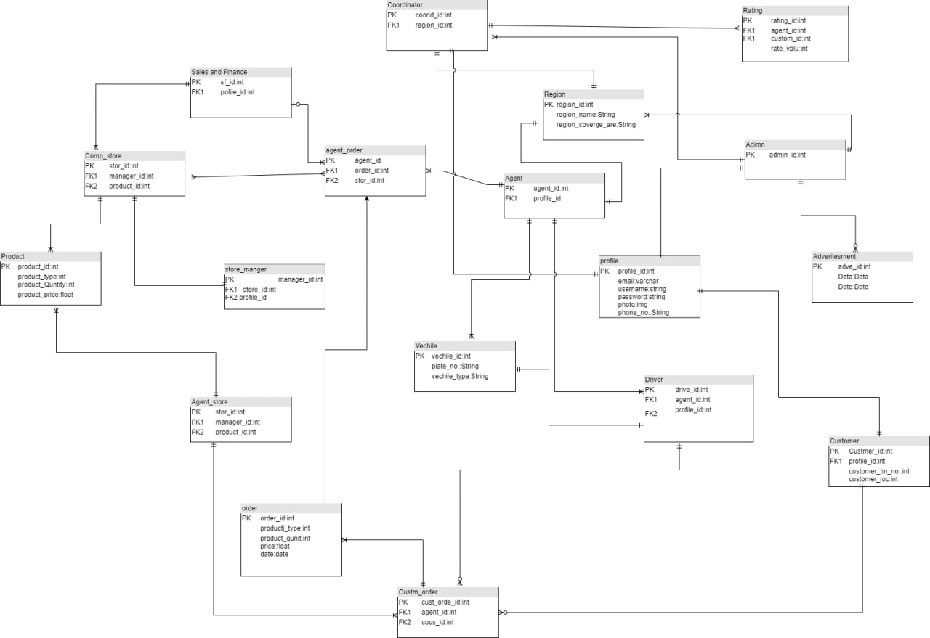

*Figure 49* *database design*

### Access control

In our system there are different actors with their respective access privilege. The following part shows actors with their privilege.

Company Admin: -has the following privilege

• Login

• Logout

• Register agent

• Register sales and finance admin

• View reports

• View detail transactions

Sales and finance Admin: -has the following privilege

• Login

• Logout

• Approve and assign order for agent

• Send slip and exit permission

• View detail orders

Agent Admin:- : -has the following privilege

• Login

• Logout

• make order

• make payment

• assign order for customer

• View delivery status

• View detail orders

• Generate report

Customer: - has the following privilege

• Login

• Logout

• make order

• make payment

• Send delivery status

• Rate agent

### 4.2.8 User interface design

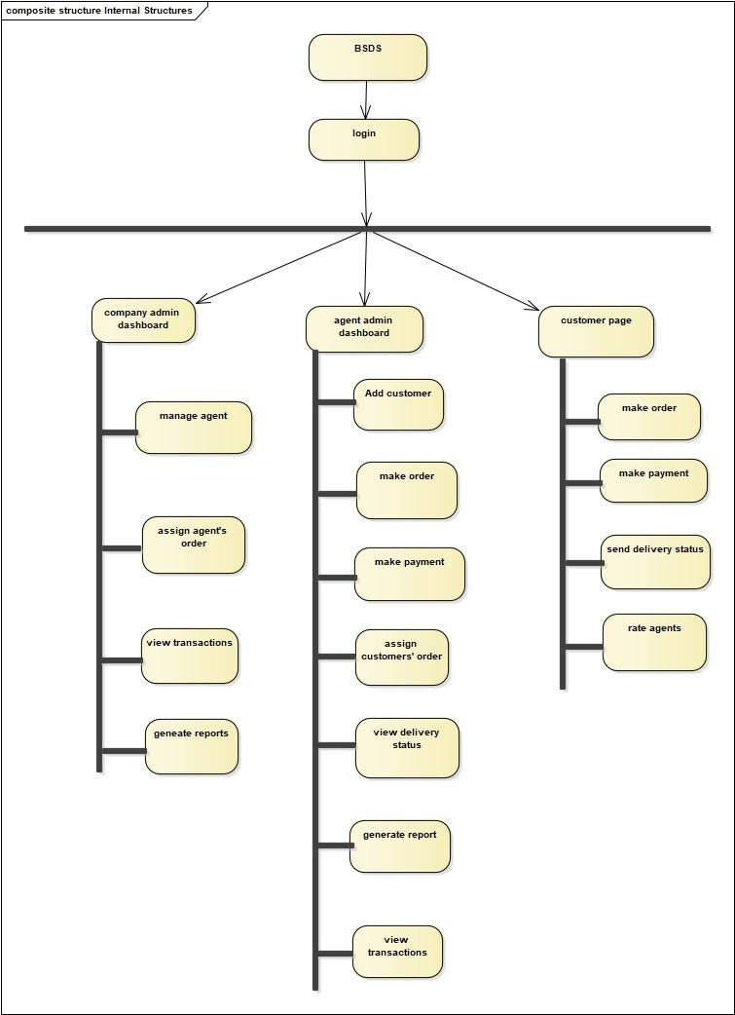

*Figure 50* *user interface design*

* 1. **Overview**

# Chapter 5: Implementation

Implementation is the process of integrating and deploying the functional and non-functional requirements of the proposed system. In this chapter, implementation of our projects will be discussed. Both the front-end and back-end development will be covered in this chapter discussion.

## Coding Standard

Adhering to coding standard of the implementation of the project is the necessary and important since it provides us different functional advantages. Coding standard have multiple use including improvement of readability and maintainability, coherent appearance of our code from each of our group members, efficiency of integration and simplify debugging. For coding standards are so enormous we have agreed to stick to below general governing guides.

* + - Naming

Naming is fundamentally essential in coding, hence we will be cautions in naming

And will be using words that are friendly to our environment, easy to remember And pronounce without involvement of digits in names. For front-end development Of components we will be stick with PascalCase and every non component will be Named camleCase. Folder names will be camelCase. CSS files will be named the Same as the component PascalCase. In case of the Back-end each naming follows snake_case. Model names will be a singular noun.

* + - Definition

Classes and Functions behaviour will be articulated because the coding toil will be

splitted among each member, we will be declaring each variable as local variable to restrain our self from risk of altering variables unintentionally.

* + - Indentation

Well-presented indentation is very crucial to enhance the readability of the code. We will

be using blank spaces and other spacing conventions like space after giving a comma between two function arguments. Indented and spaced nested block. Proper Indentation will be there at the beginning and at the end of each block in the program. All braces will start from a new line and the code following the end of braces also start from a new line. We will be considerate of group members screen width on our length of horizontal alignment of codes.

* + - File organization

We will be instantiating the project with a unique main folder in this folder we will place

the basics with single folder and there will be different unique folder for each specific application in chorological order.

* + - Commenting and Documenting

Commenting is very essential in helping understand the code and easing the debugging

process. Our comments will be short and informative enough about the behaviour and mechanism of the code.

## Development Tools

Our project encompass both the front end and back end development uses the following development tools. Django is a high-level Python web framework that encourages rapid development and clean, pragmatic design. Built by experienced developers, it takes care of much of the hassle of web development, so you can focus on writing your app without needing to reinvent the wheel. It’s free and open source. In our project we are using django for back-end development. React (also known as React.js or ReactJS) is a free and open-source front-end JavaScript library for building user interfaces based on UI components. It is maintained by Meta (formerly Facebook) and a community of individual developers and companies. React can be used as a base in the development of single-page or mobile applications. However, React is only concerned with state management and rendering that state to the DOM, so creating React applications usually requires the use of additional libraries for routing, as well as certain client-side functionality. So we will be using react for the front-end development or in designing the interfaces.

## Prototype

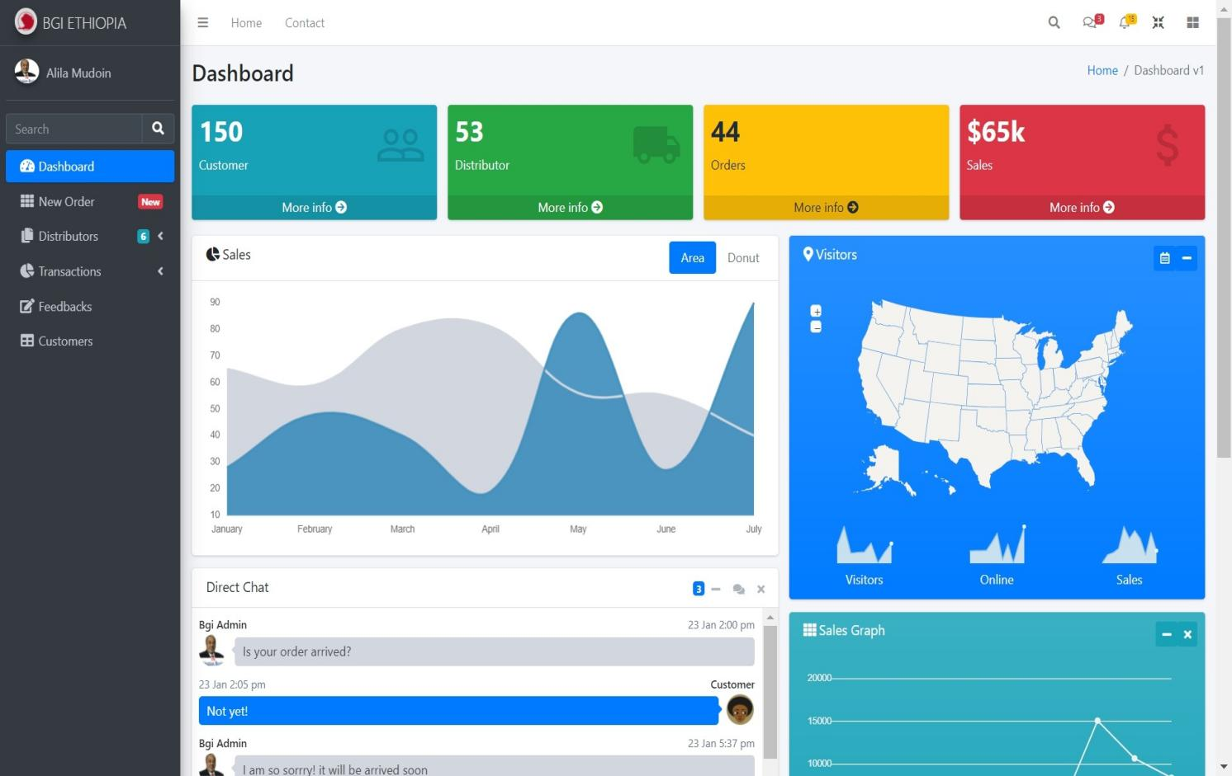

*Figure 51* *prototype 1*

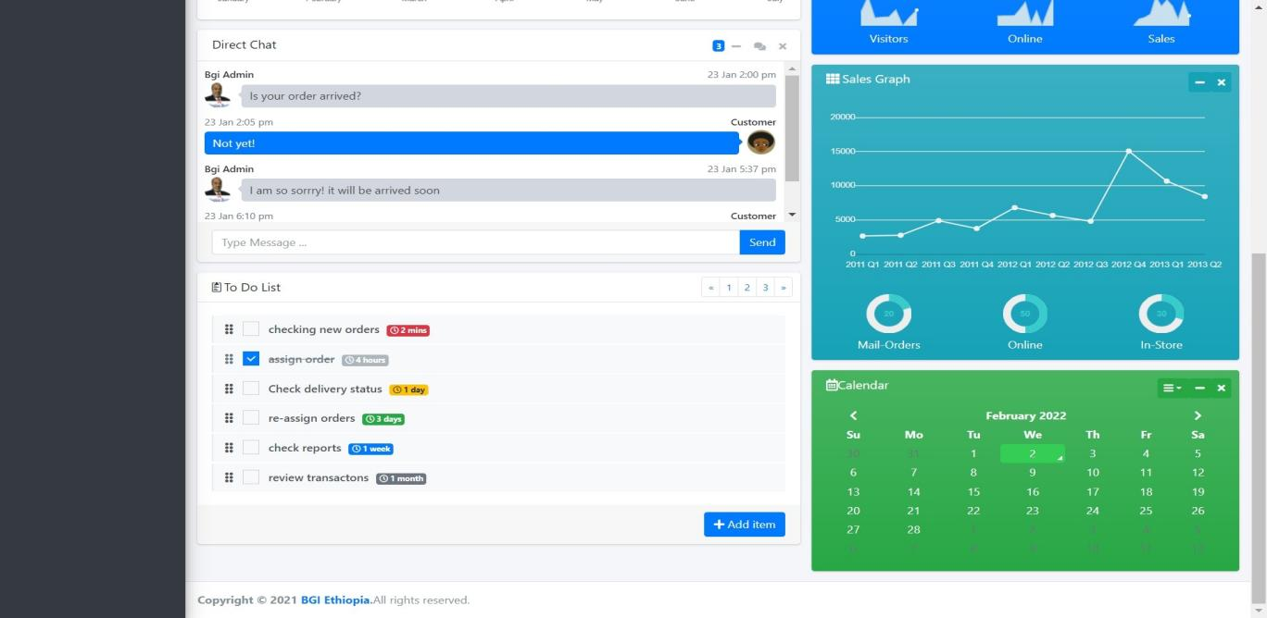

*Figure 52* *prototype 2*

## Implementation detail

|  |  |
| --- | --- |
| **Components** | **Functions** |
| **Django user models** | This is the user database table which is user for authentications. |
| **Django URLs** | This is a python code which routes the URLs to a view in the system. |
| **Django Views** | This also a python code which does the login and maps the URLs with templates. |
| **Django templates** | Templates are the HTML code which are served on the web browser. |
| **Django static file** | collects static files from each applications (and any other places you specify) into a single location that can easily be served in  production. |
| **Django Media** | can serve the static media from Django |
| **Jinja** | is a fast, expressive, extensible templating engine. Special placeholders in the template allow writing code similar to Python syntax |

*Table 18* *implementation detail*

## 5.6 Testing Plan

A **Test** Plan is a detailed document that describes the test strategy, objectives, schedule, estimation, deliverables, and resources required to perform testing for a software product. Test Plan helps us determine the effort needed to validate the quality of the application under test. The test plan serves as a blueprint to conduct software testing activities as a defined process, which is minutely monitored and controlled by the test manager.

5.6.1 What is the Importance of Test Plan?

Making Test Plan document has multiple benefits

* Help people outside the test team such as developers, business managers, customers understand the details of testing.
* Test Plan guides our thinking. It is like a rule book, which needs to be followed.
* Important aspects like test estimation, test scope,[Test Strategy](https://www.guru99.com/how-to-create-test-strategy-document.html)are documented in Test Plan, so it can be reviewed by Management Team and re-used for other projects.

We will follow the following test plan for our system:

1. Functionality Testing

Functionality Testing of a Web-based system is a process that includes several testing parameters like user interface, APIs, database testing, security testing, client and server testing and basic website functionalities. Functional testing is very convenient and it allows users to perform both manual and automated testing. It is performed to test the functionalities of each feature on the website.

Web based Testing Activities includes:

**Test all links**in our webpages are working correctly and make sure there are no broken links. Links to be checked will include –

* Outgoing links
* Internal links
* Anchor Links

**Test Forms** are working as expected. This will include-

* Scripting checks on the form are working as expected. For example- if a user does not fill a mandatory field in a form an error message is shown.
* Check default values are being populated
* Once submitted, the data in the forms is submitted to a live database or is linked to a working email address
* Forms are optimally formatted for better readability

**Test HTML and CSS** to ensure that search engines can crawl our site easily. This will include

* Checking for Syntax Errors
* Standard Compliance.
* Readable Color Schemas

2. Usability testing

[Usability Testing](https://www.guru99.com/usability-testing-tutorial.html) has now become a vital part of any web-based project. It can be carried out by testers group or a small focus group similar to the target audience of the web application.

**Test the site Navigation:**

* Menus, buttons or Links to different pages on our site should be easily visible and consistent on all webpages

**Test the Content:**

* Content should be legible with no spelling or grammatical errors.
* Images if present should contain an “alternative” text

3. Database Testing

Database is one critical component of your web application and stress must be laid to test it thoroughly. Testing activities will include-

* Test if any errors are shown while executing queries
* Data Integrity is maintained while creating, updating or deleting data in database.
* Check response time of queries and fine tune them if necessary.
* Test data retrieved from the database is shown accurately in your web application

4. Compatibility testing

Compatibility tests ensures that our web-based displays correctly across different devices. This would include-

**Browser Compatibility Test**: Same web-based system in different browsers will display differently. we need to test if our web-based system is being displayed correctly across browsers, JavaScript authentication is working fine. we may also check for[Mobile](https://www.guru99.com/mobile-testing.html)Browser Compatibility.

The rendering of web elements like buttons, text fields etc. changes with change in Operating System. We Make sure the website works fine for various combination of Operating systems such as Windows, Linux, Mac and Browsers such as Firefox, Internet Explorer, Safari etc.

5. Security testing

[Security Testing](https://www.guru99.com/what-is-security-testing.html) is vital for online payment based web-based system that store sensitive customer information like credit cards, transaction number, password ,email...etc.

* Testing Activities will include-
* Test unauthorized access to secure pages should not be permitted
* Restricted files should not be downloadable without appropriate access
* Check sessions are automatically killed after prolonged user inactivity

6. Crowd Testing

We will select a large number of people (crowd) to execute tests which otherwise would have been executed a select group of people in the company. Crowdsourced testing is an interesting and upcoming concept and helps unravel many unnoticed defects.

5.6.2 Schedule for test plan

|  |  |  |  |
| --- | --- | --- | --- |
| **No** | **Test type** | **Starting-date** | **Ending-date** |
| **1** | Functionality Testing | April 9 | April 15 |
| **2** | Usability testing | April 23 | April 29 |
| **3** | Database Testing | April 1 | April 7 |
| **4** | Compatibility testing | May 2 | May 9 |
| **5** | Security testing | April 16 | April 21 |
| **6** | Crowd Testing | May 9 | May 15 |

*Table 19 schedule for test plan*

# *References*

*source:* [*https://bgiethiopia.com/index*](https://bgiethiopia.com/index) *online*

*source:* [*https://www.djangoproject.com/*](https://www.djangoproject.com/) *online*

*source:* [*https://www.wikizero.com/en/React_(JavaScript_library)*](https://www.wikizero.com/en/React_(JavaScript_library)) *online*

*source:* [*https://en.wikipedia.org/wiki/Unified_Modeling_Language*](https://en.wikipedia.org/wiki/Unified_Modeling_Language) *online*